

**Boeing Company**

***Secure Software Development***

**Sponsor Lead:**

**Development Team:**

Tung Dang <[tdang21@uw.edu](mailto:tdang21@uw.edu)>

Jabriel Phan <[jabrip@uw.edu](mailto:jabrip@uw.edu)>

Thomas Nguyen <[ttn99@uw.edu](mailto:ttn99@uw.edu)>

**Table of Contents**

**1. Introduction/Required Materials** **3**

**2. Environment Setup** **4**

2.1 Java and Eclipse for Java EE 4

2.1.1 Java SE and JDK 4

2.1.2 Apache Maven 6

2.1.3 Eclipse for Java EE 8

2.1.4 Git/Github 9

2.1.5 MongoDB Community Server 9

2.2 Virtual Vehicles API 10

2.3 Insomnia 14

**3. SAST Tool Setup** **16**

3.1 SpotBugs/FindBugs 16

3.1.1 Install SpotBugs via Marketplace in eclipse: 16

3.1.2 Install SpotBugs through download Zip folder: 19

3.2 DeepCode 21

3.2.1 Via Marketplace 22

3.2.2 Using DeepCode Website 23

**4. Miscellaneous** **26**

**5. Code Samples** **29**

5.1 Input Validation and Data Sanitization 29

5.1.2 Reliance on Default Encoding 29

5.2 Methods 31

5.2.1 An equals() Method Must Have A Corresponding hashCode() Method 31

5.2.2 Confusing Similar Signature 32

5.3 Object Orientation 34

5.3.1 Do Not Use Public Static Nonfinal Variables 34

5.4 Resources 36

5.4.1 Close Any Resources After Their Use Is Over 36

**References/Download Links** **38**

# **1. Introduction/Required Materials**

This document covers installation of the environment for running the virtual vehicles REST API. Additionally, we will also cover setting up the SAST tools we used when exploring the API. Links to all of the software used will be provided at the end. The following technologies were used (note: bolded items are items which need to be manually installed):

* *RestExpress*: provides tools to enable quick creation of RESTful microservices
* ***Java EE***: primary development language
* *Netty*: Java network application framework
* ***Apache Maven***: Dependency and project management
* ***MongoDB***: database support
* *JSON Web Tokens (JWT)*: claims based authentication
* *Apache Log4j 2*: logging
* *JUnit*: unit testing
* ***Eclipse for Java EE***: IDE
* ***Git and GItHub***: chain management
* ***Insomnia***: REST API testing

In addition to the above technologies, the following SAST and DAST tools were used:

* *SpotBugs/FindBugs (SAST)*
* *DeepCode (SAST)*
* *OWASP ZAP (DAST)*
* *Snyk (DAST)*

All of the following instructions in this document will only apply to a Windows 64-bit operating system. Download links can be found here.

# **2. Environment Setup**

## 2.1 Java and Eclipse for Java EE

### 2.1.1 Java SE and JDK

1. Download the JDK installer from Oracle’s website (version 15.0.1 shown here):
2. Run the .exe file and follow the wizard instructions: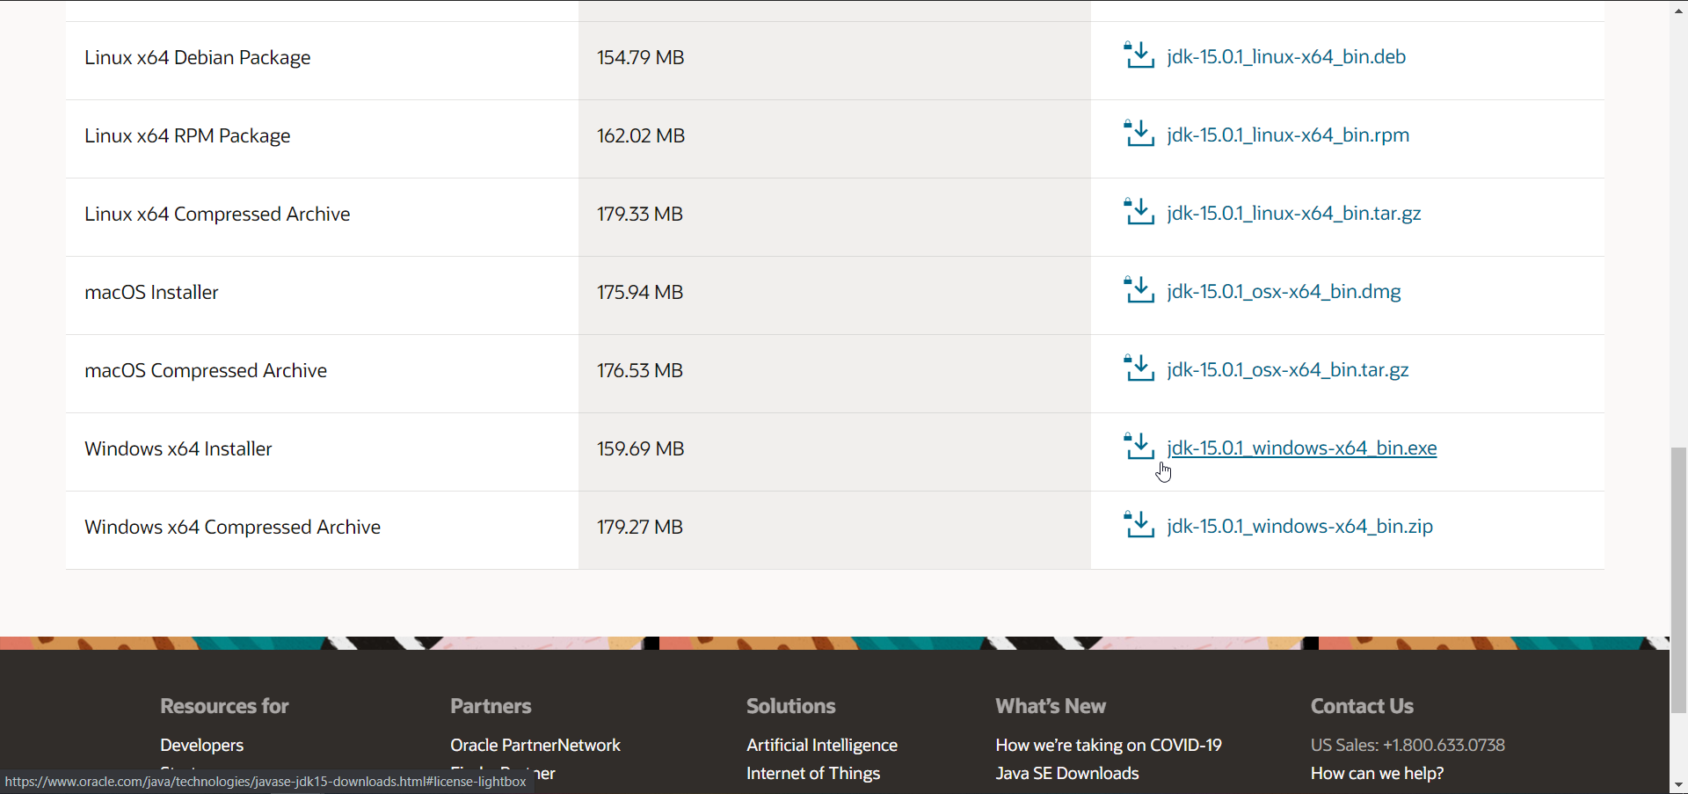
3. Navigate to System Properties and to Environment Variables: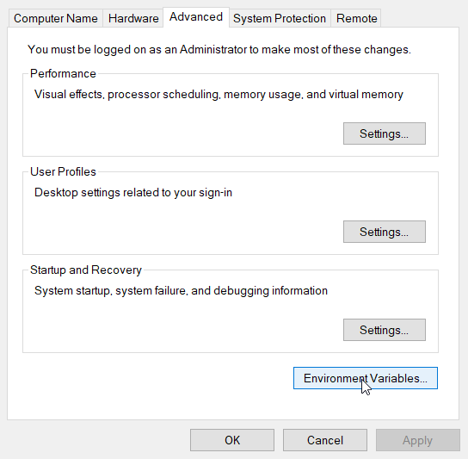
4. Click Path and select edit:

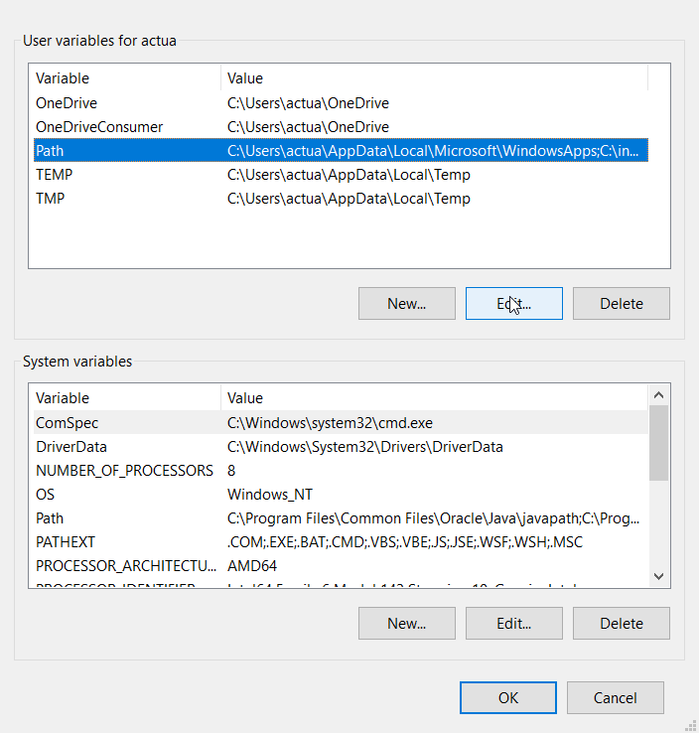

1. Add a new variable with the path to the bin folder as shown below: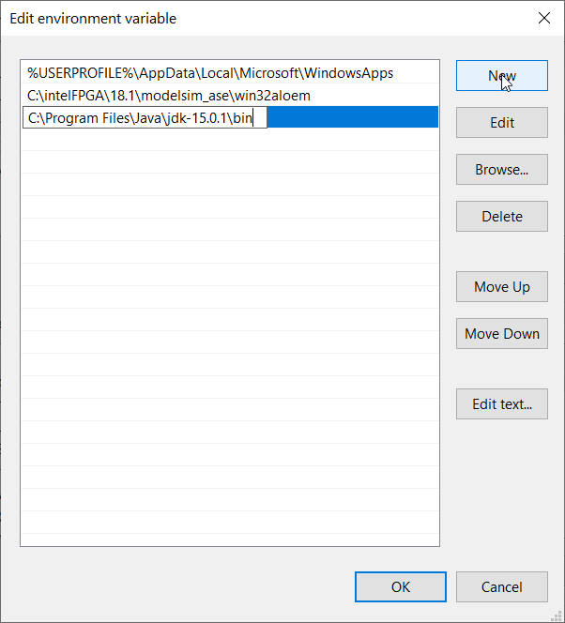

### 2.1.2 Apache Maven

1. Download the binary zip archive from Apache’s website (version 3.6.3 shown here):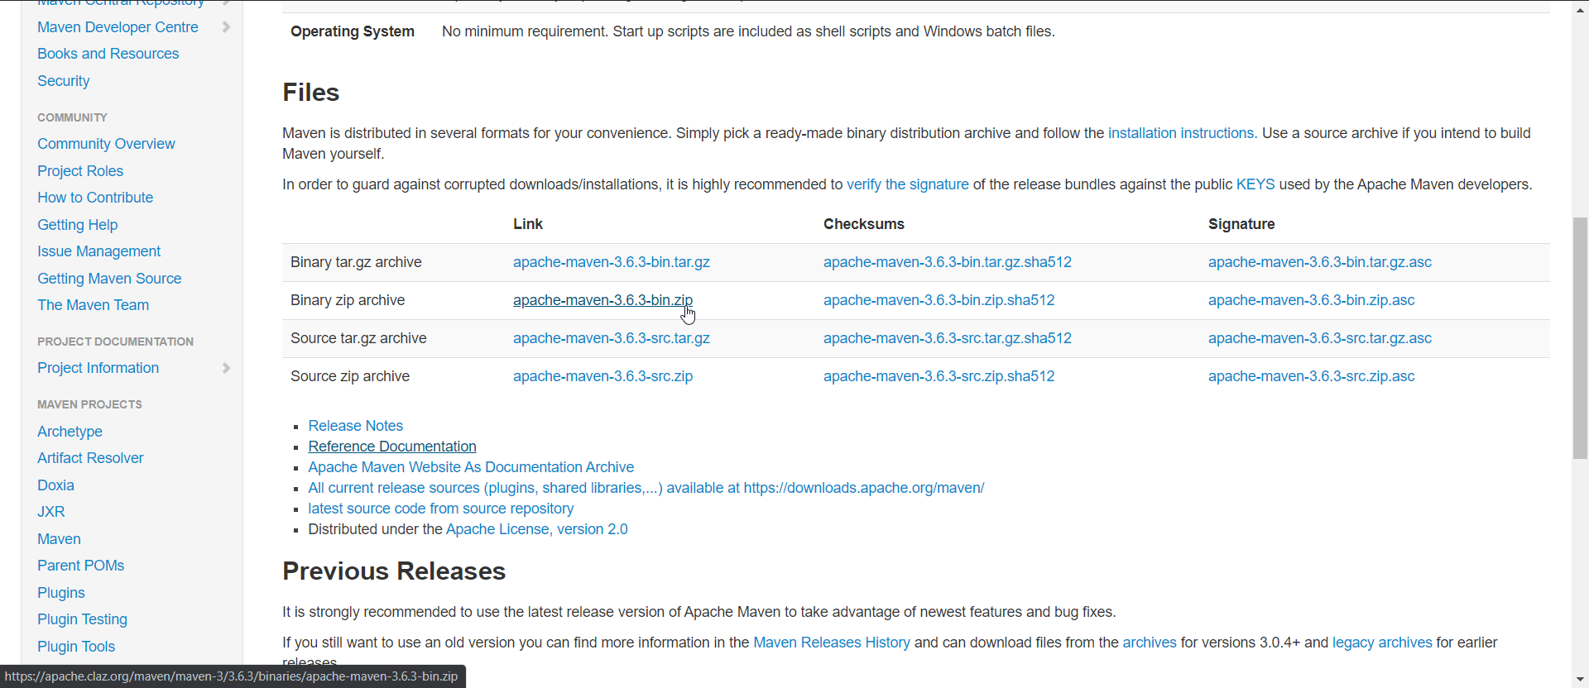
2. Extract and copy the archive’s contents to your desired folder (e.g. C:\Program Files):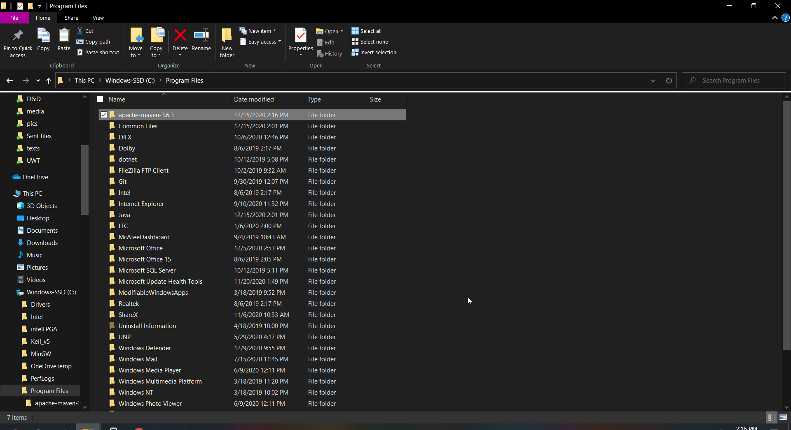
3. Go to System Properties and edit the Environment Variables:
4. Add the path to Maven’s bin folder: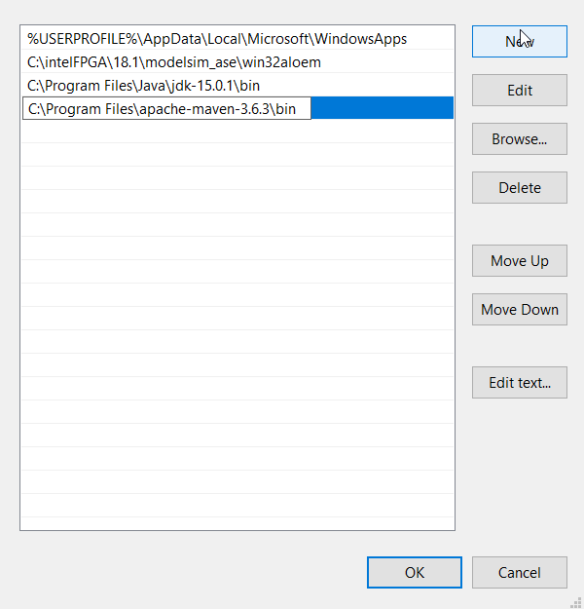
5. On the command prompt, type “mvn -v” to confirm the installation: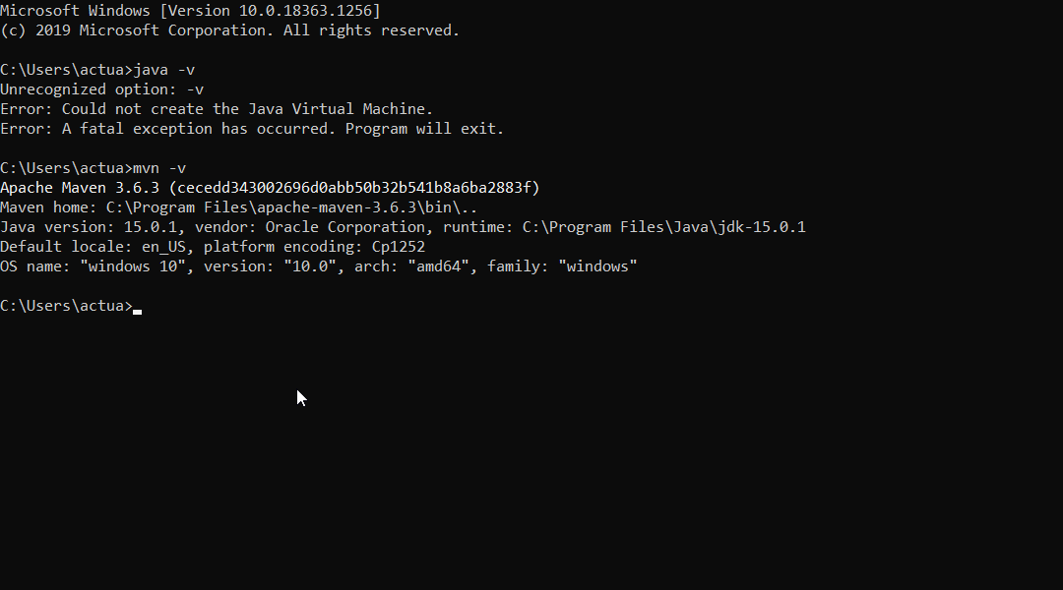

### 2.1.3 Eclipse for Java EE

1. Download the Windows version from the Eclipse website: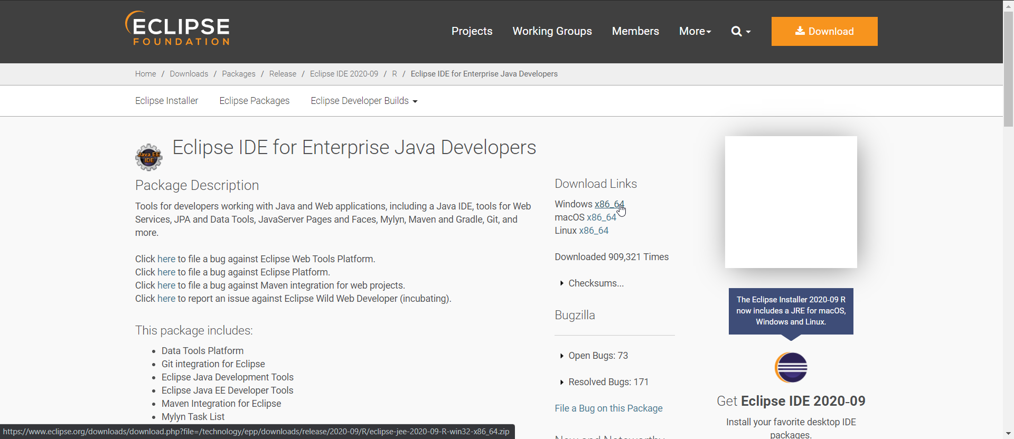
2. Extract and copy the archive’s contents to your desired folder (e.g. C:\Program Files):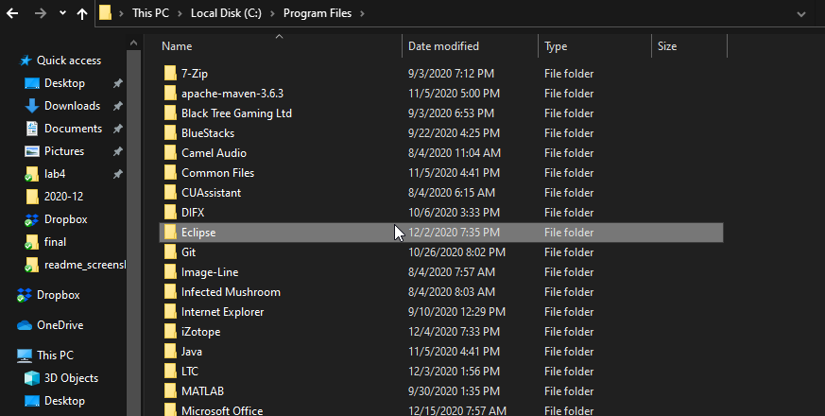
3. To run Eclipse JEE, run “eclipse.exe.” To make it easier, add a shortcut to the desktop:

### 2.1.4 Git/Github

1. Download the installer from Git’s website and follow the wizard instructions: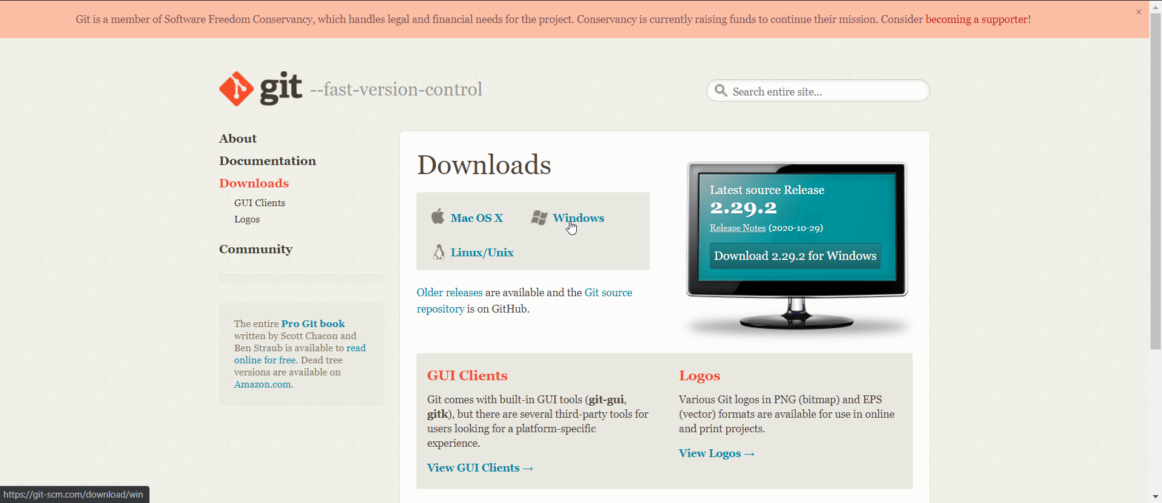
2. You can run the following commands to verify Git’s installation and add the name and email address which will be associated with all of your commits: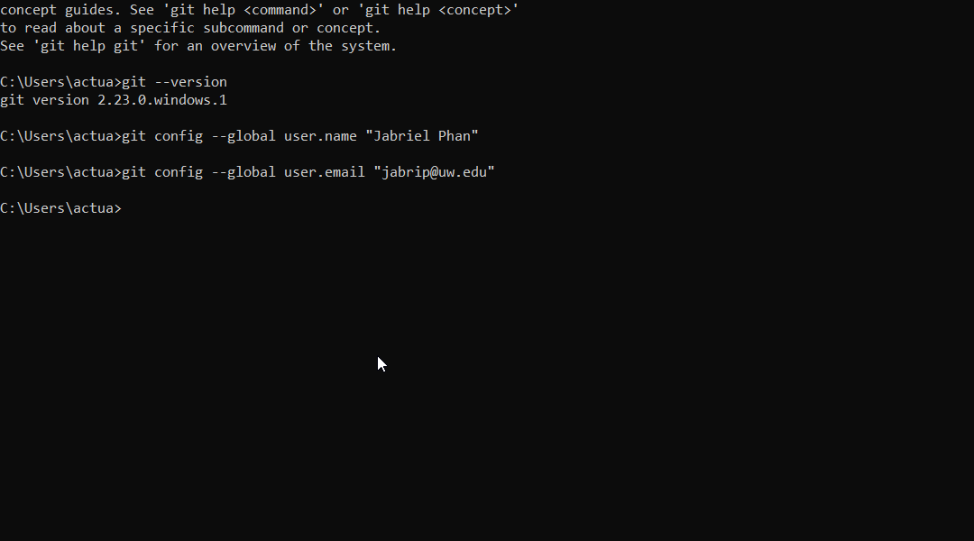

### 2.1.5 MongoDB Community Server

1. Download the installer from MongoDB’s website and follow the wizard instructions. The “Complete” option was chosen and MongoDB is installed as a service (MongoDB Compass is optional):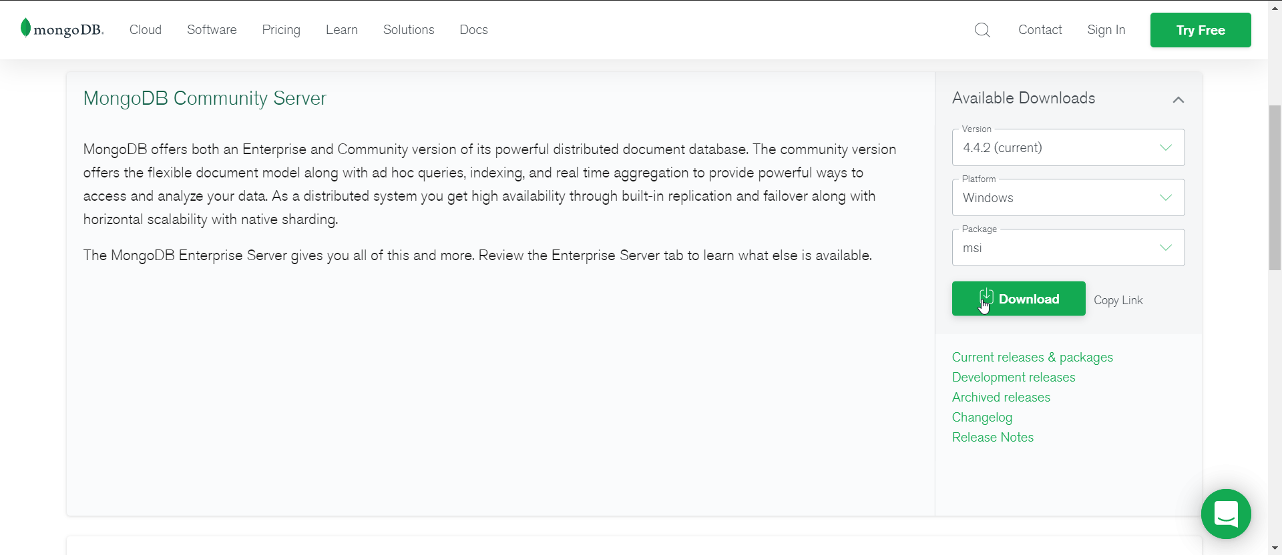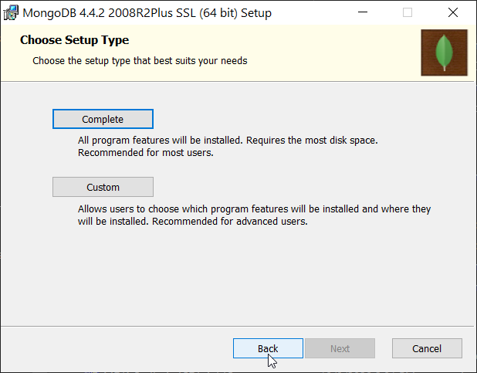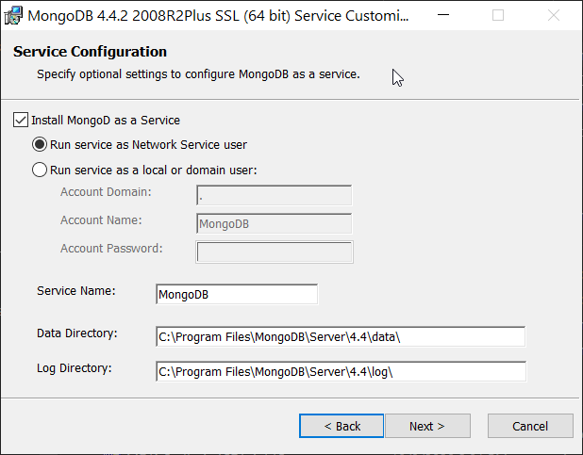

## 

## 2.2 Virtual Vehicles API

1. You can download the Virtual Vehicles Demo to your desired directory by using “git clone” and passing the link associated on the GitHub repository in the references section: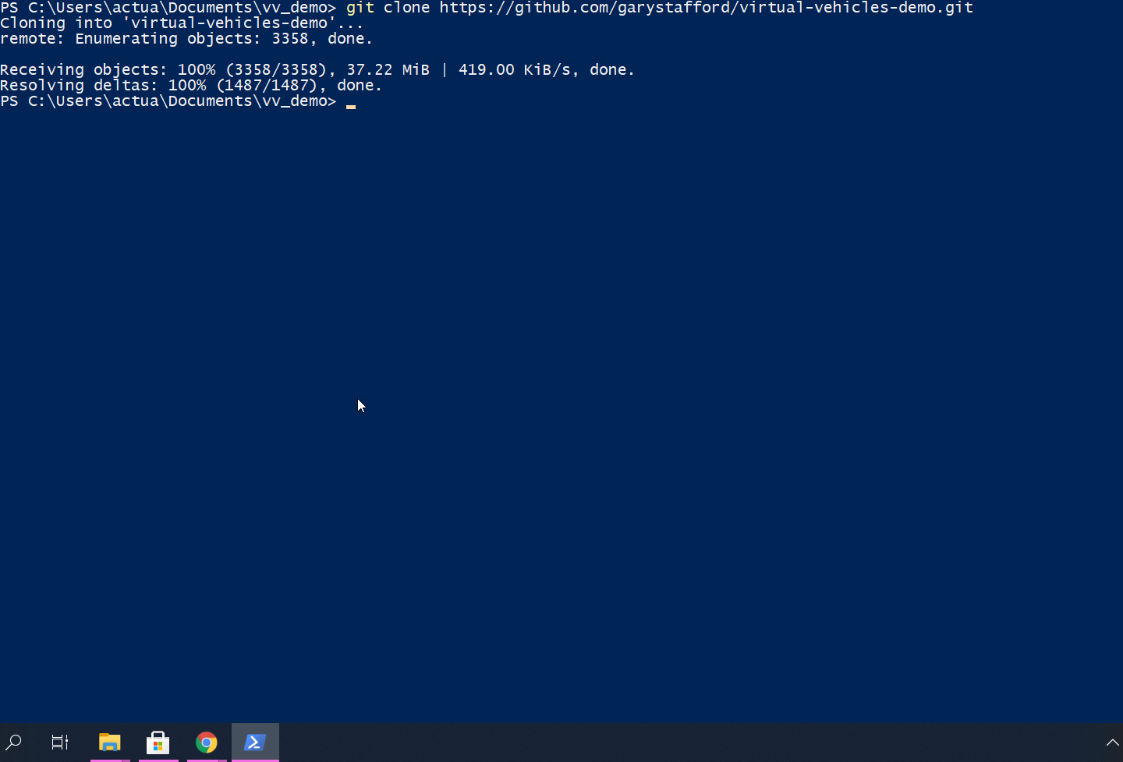
2. When opening Eclipse, change the workspace to the directory where you downloaded the repository: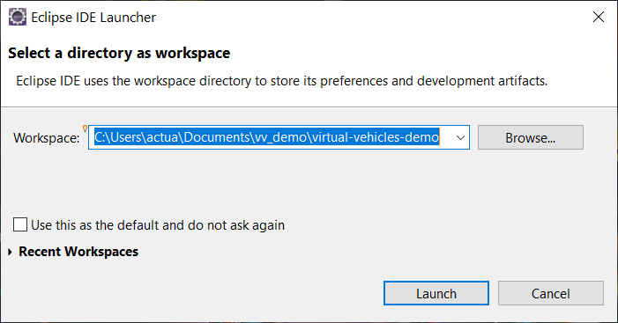
3. On the Project Explorer window, click “Import projects…”: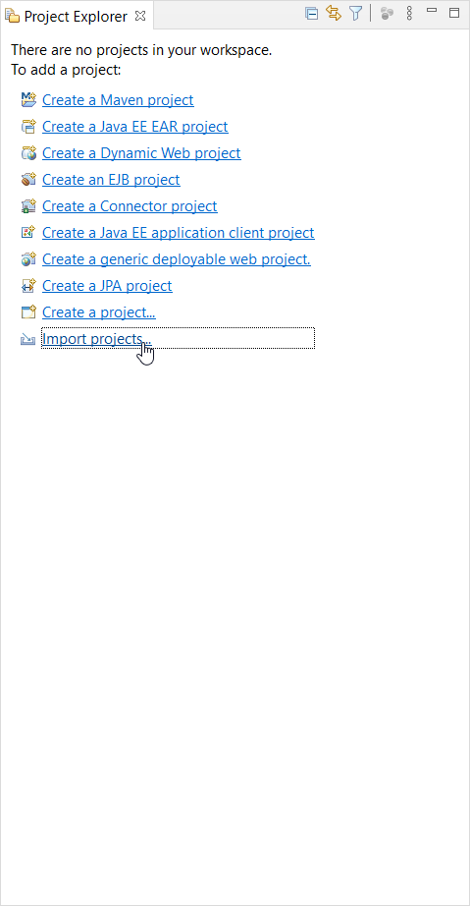
4. Under General, select “Projects from Folder or Archive”: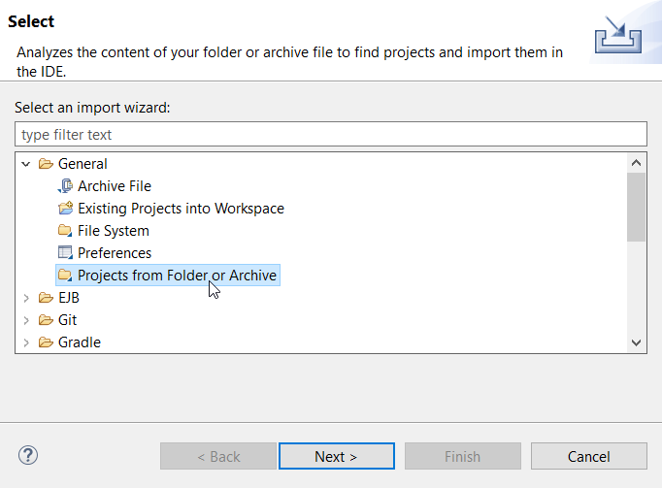
5. Select the directory where the demo resides: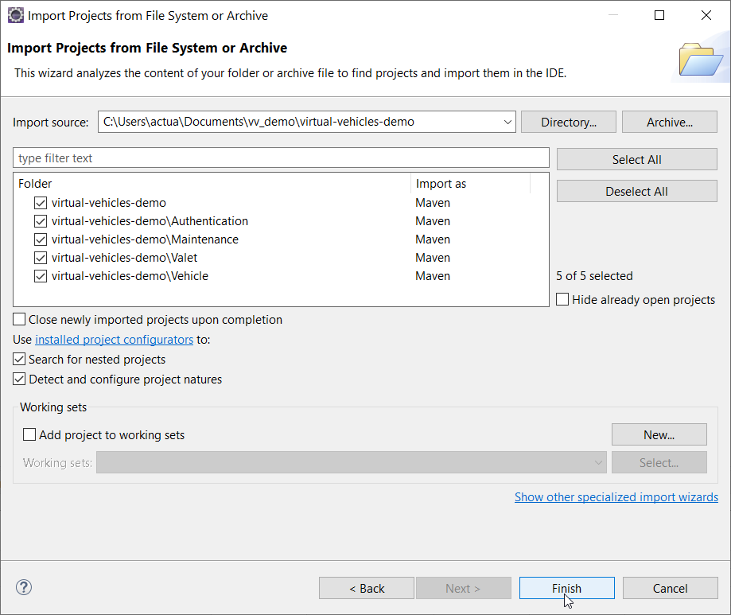
6. Each service should have its own project as follows (you may have to wait for Eclipse to update some dependencies):
7. In order to start each service, you can run Main.java: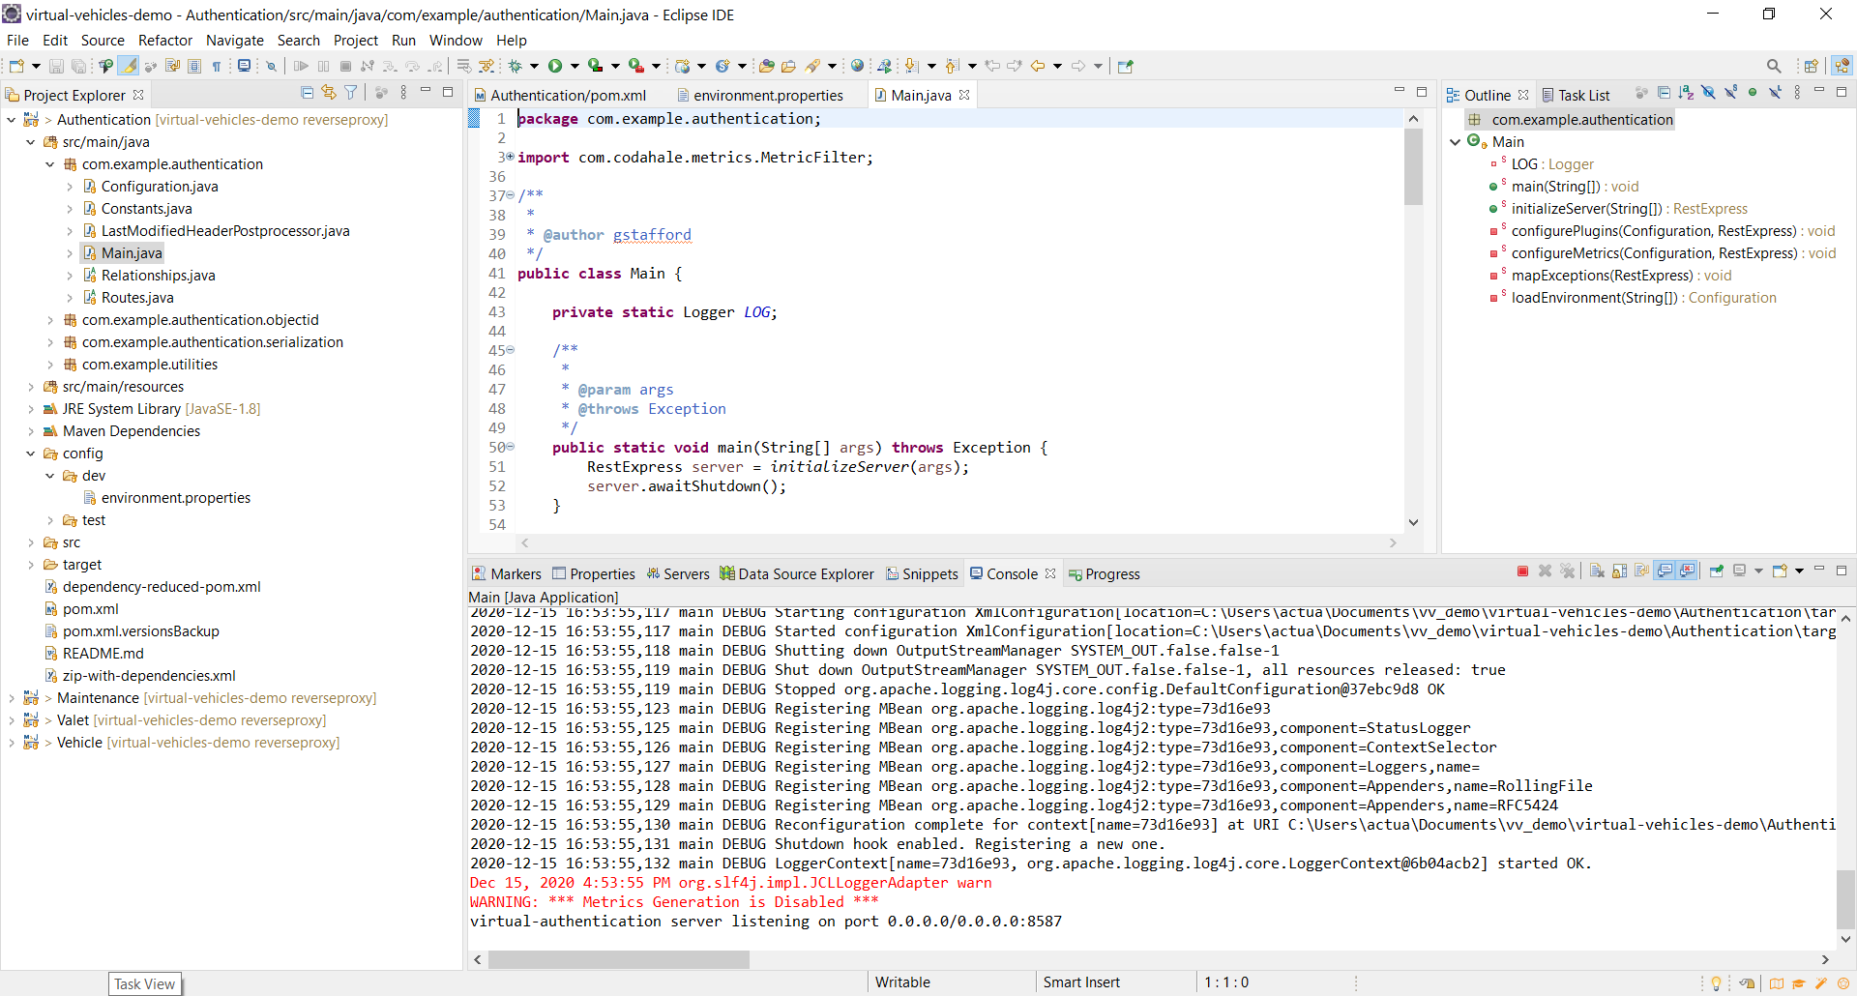

## 

## 2.3 Insomnia

1. Download Insomnia Core from Insomnia’s website and follow the wizard instructions: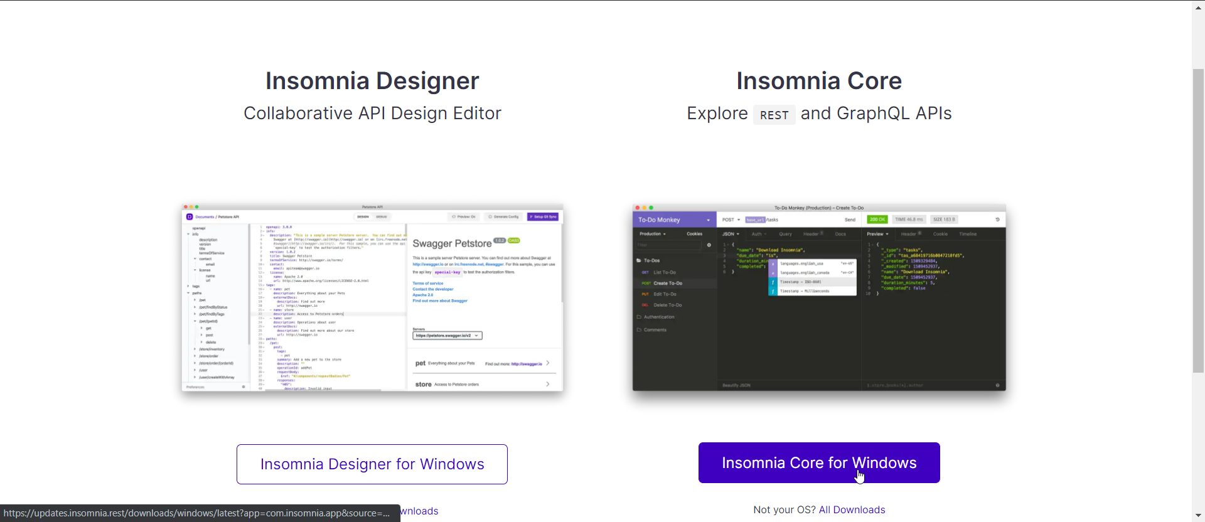
2. Opening the executable file should lead to the following:
3. In order to test some of the services, we had to modify the code in the following: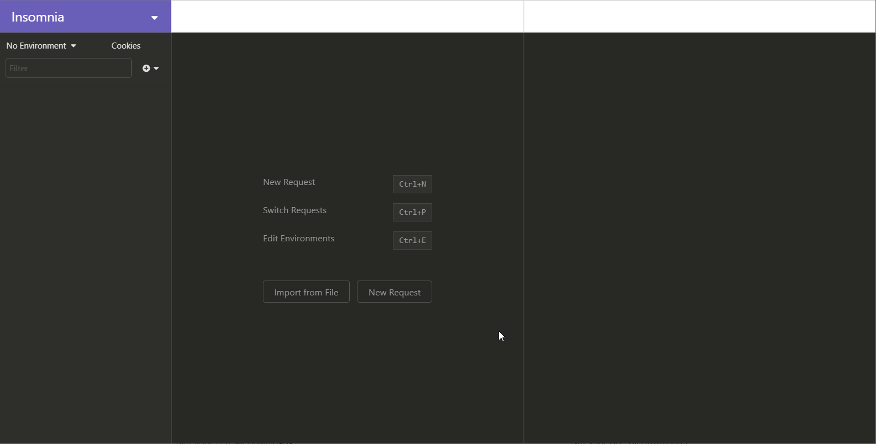
   1. Under the environment properties, we had to add the port number to the base url:

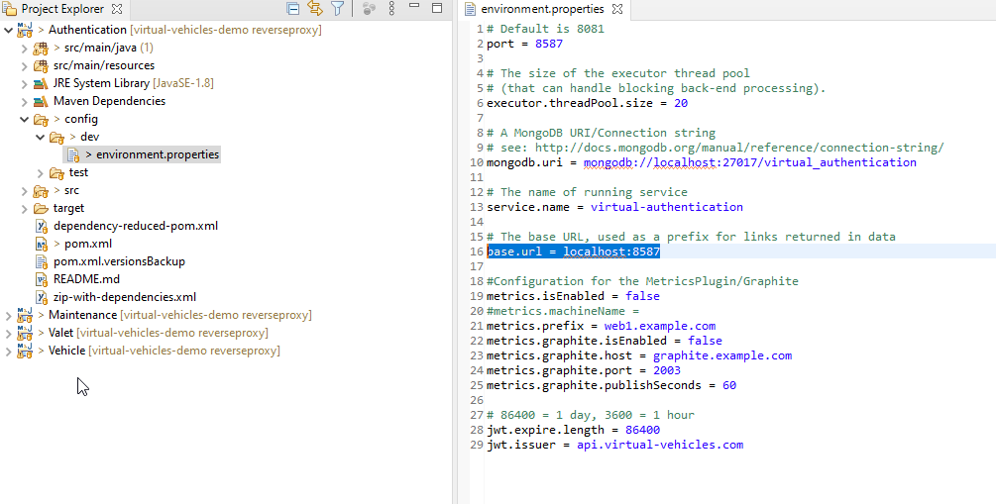

* 1. In AuthenticateJwt.java for each service, we had to add the port number on the highlighted line:

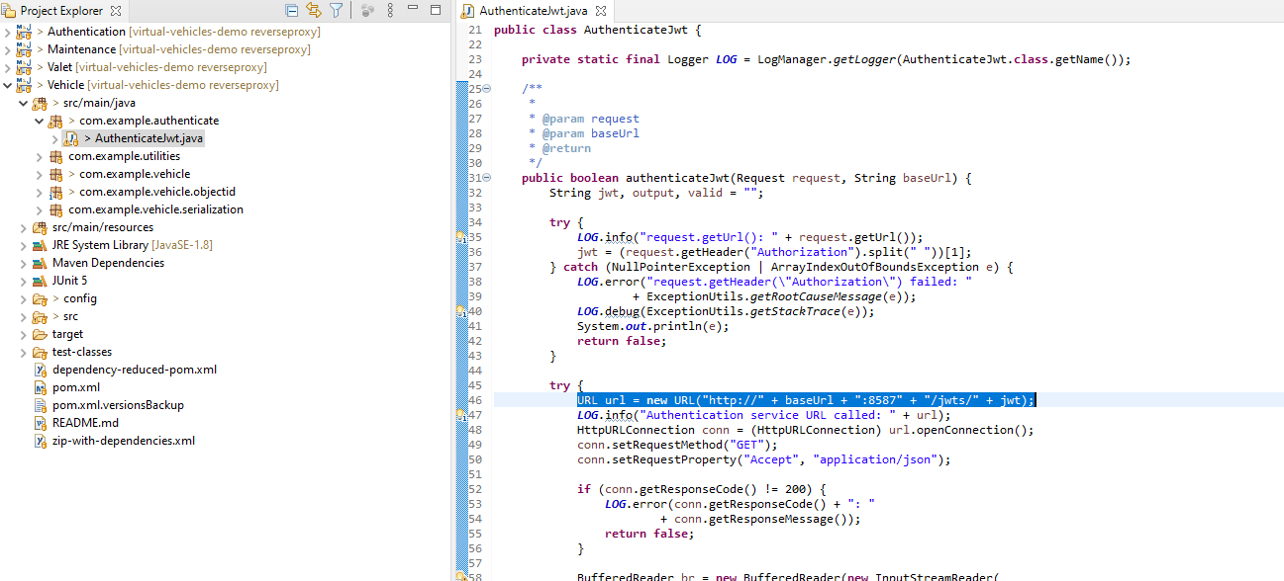

# **3. SAST/DAST Tool Setup**

## 3.1 SpotBugs/FindBugs

There are 2 methods we use to set up SpotBugs to test it in our source code.

1. Via Marketplace Eclipse plugin
2. Download zip file from SpotBugs Website(Recommended)

### 3.1.1 Install SpotBugs via Marketplace in eclipse:

1. Open Marketplace in Eclipse

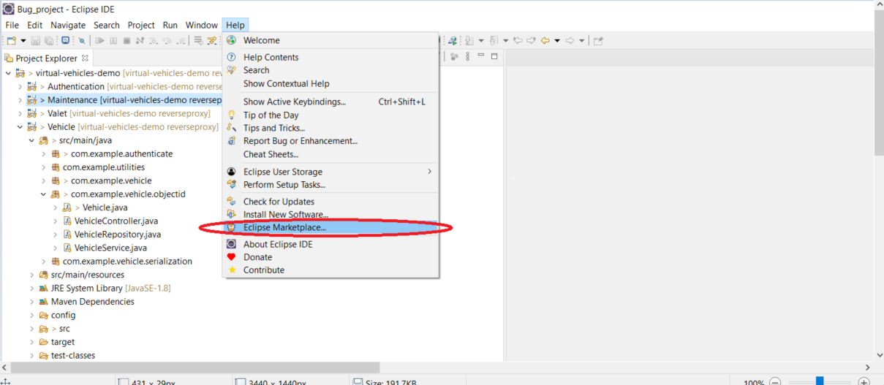

1. Search SpotBugs and Install

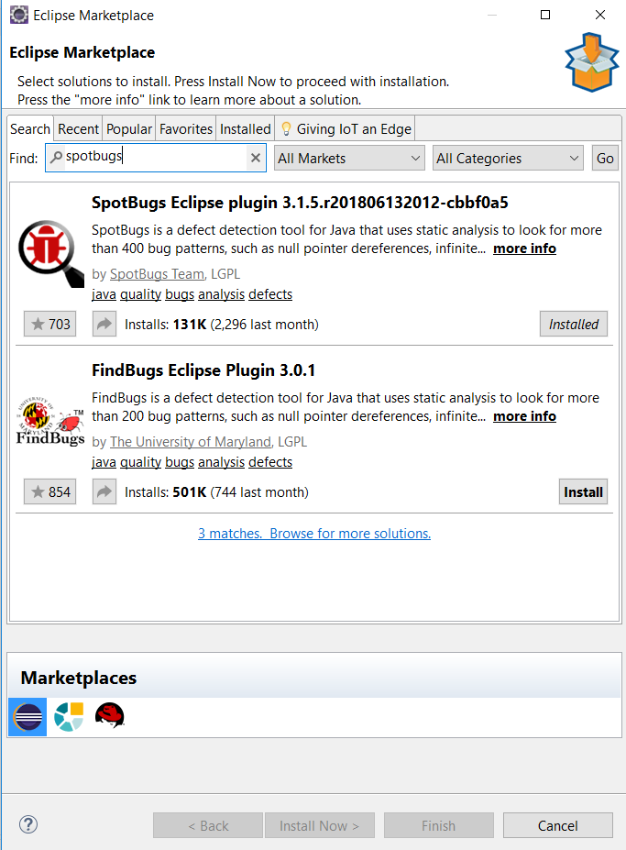

1. Use SpotBugs by right click on the source code you want to investigate and select Spotbugs option

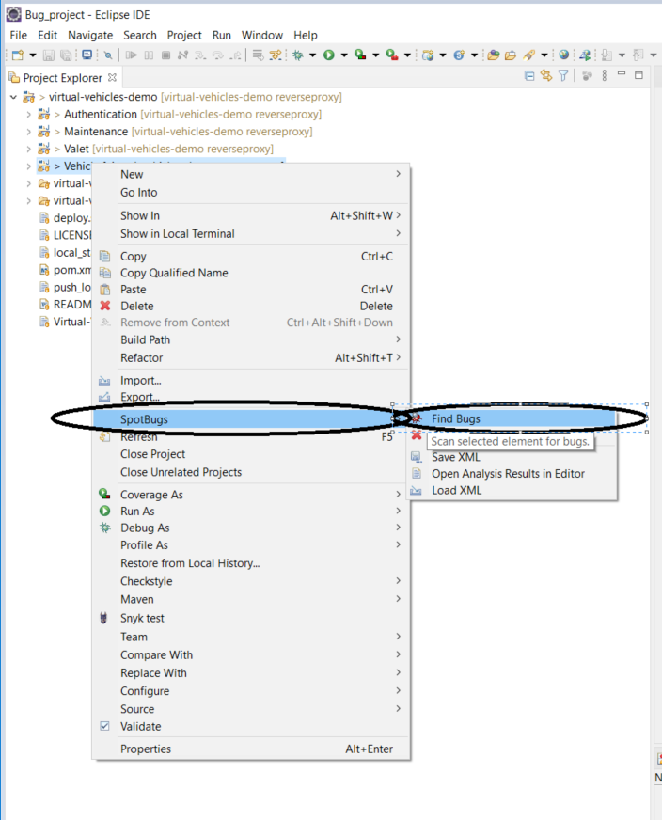

### 3.1.2 Install SpotBugs through download Zip folder:

1. Use the link in the Download Links section for SpotBugs and download the zip folder option.

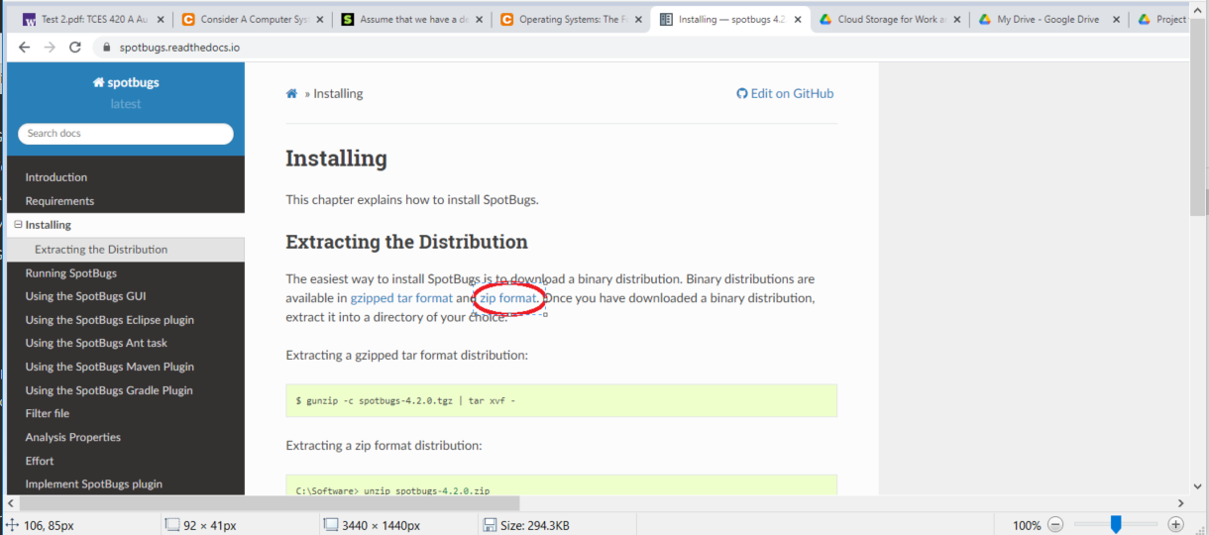

1. Unzip the zip folder in the desired location.

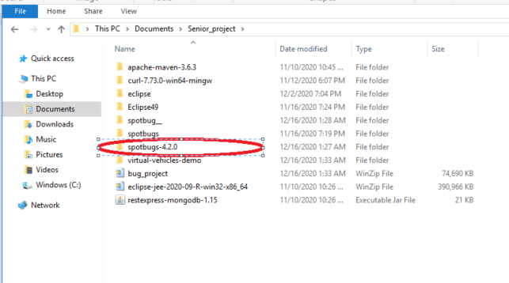

1. How to use SpotBugs: Go open the SpotBugs>bin>Spotbugs(window Batch File)

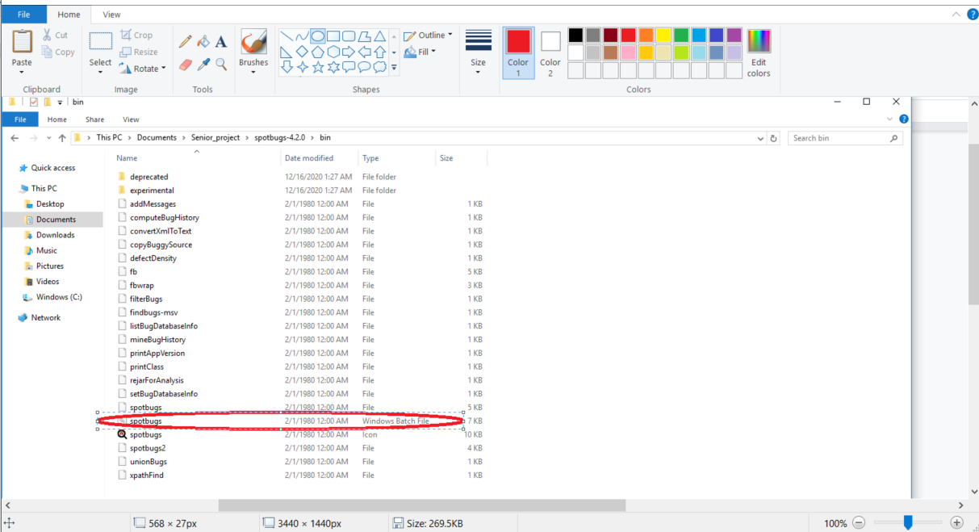

1. To test Source code with SpotBugs, first, create a new Project.

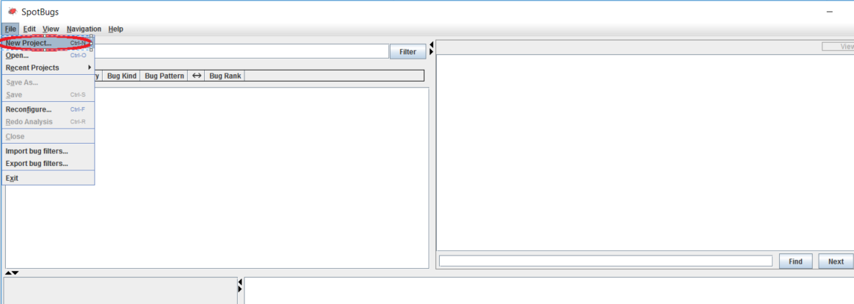

1. Click on Add in the Classpath for Analysis section, then go to the Virtual Vehicles project, select the source code you want to investigate. In this case, we want to test the Authentication service. After configuring the path, press Analysis.

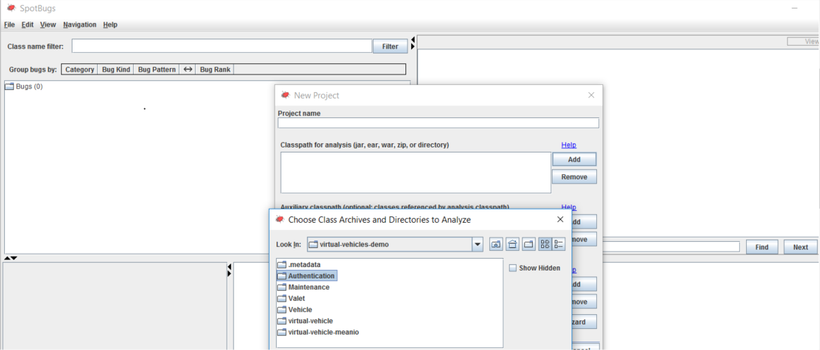

1. Result.

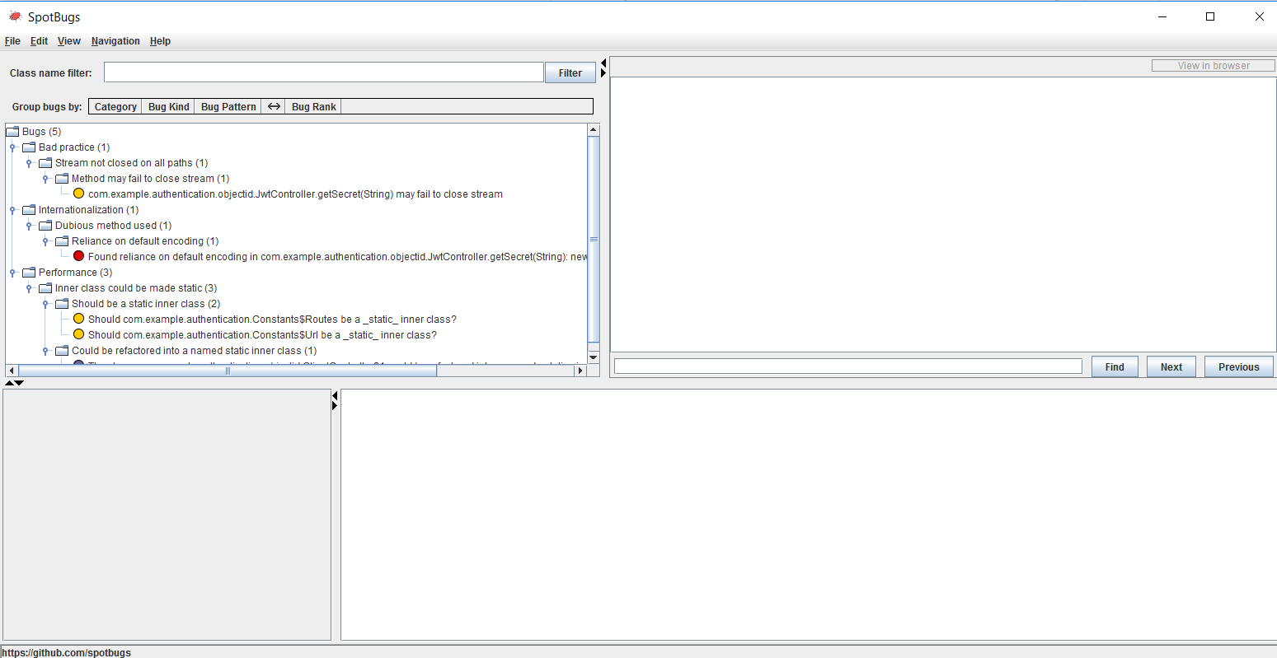

## 3.2 DeepCode

There are 2 methods we use to set up deepcode to test it in our source code.

1. Via Marketplace eclipse plugin(recommended if you want to test on your local repository)
2. Via Deepcode Website(recommended if you want to test existed project on remote repository)

### 3.2.1 Via Marketplace

1. Repeat step 1 & 2 from the setting Spot Bugs but replace SplotBugs with DeepCode.
2. After Eclipse restarts, it will ask to login to your GitHub, BitBucket, or GitLab account.
3. After logging in, it will ask if you want to analyze each project of the Virtual Vehicle Demo. Click okay or confirm.
4. After DeepCode is finished analyzing the projects, click on markers in the console screen, and then click on DeepCode to view any errors or warnings.

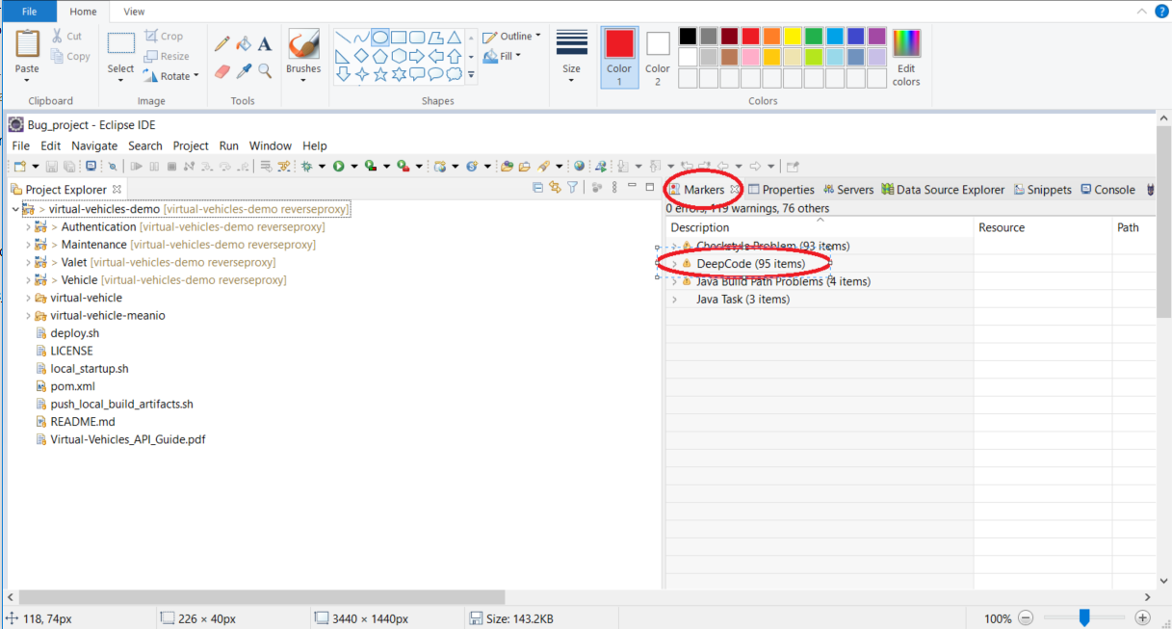

1. Result of After using Deepcode tool

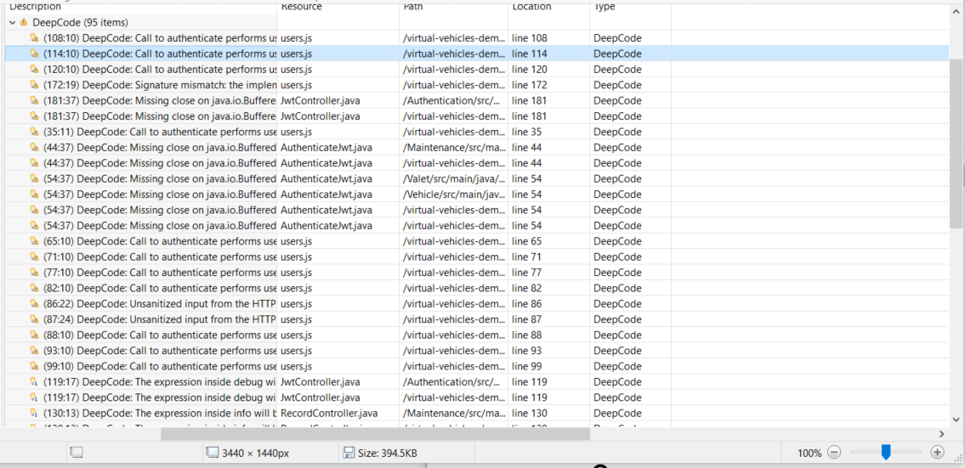

### 3.2.2 Using DeepCode Website

1. Go to the DeepCode Website using the Deepcode link in the References section.

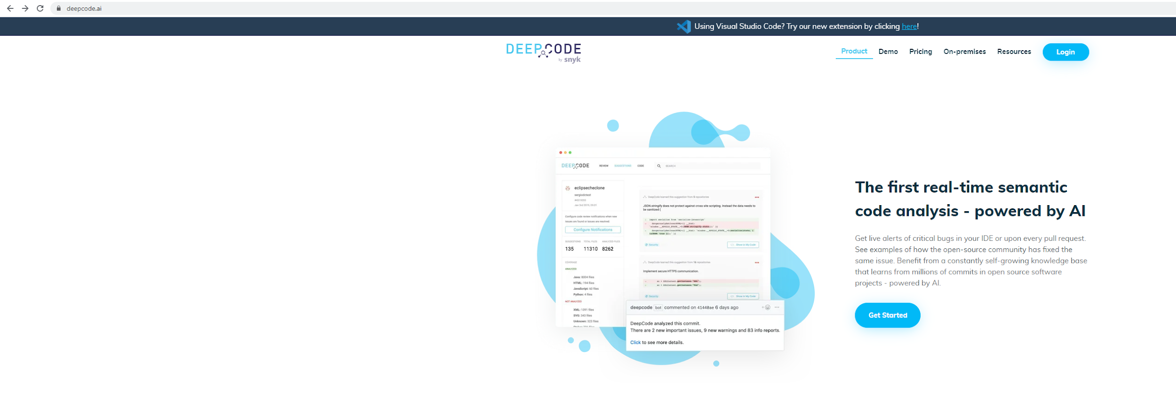

1. Login using GitHub, Bitbucket or GitLab.

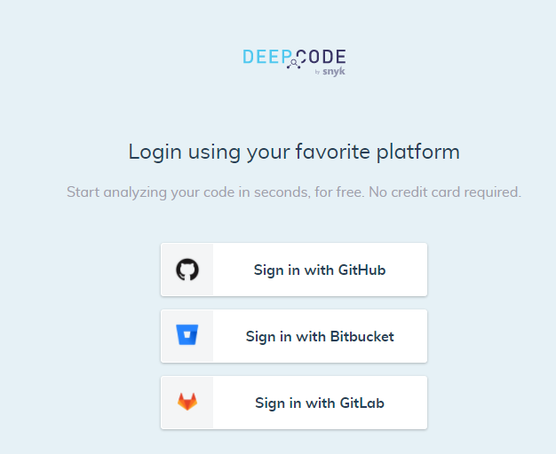

1. Search for your own or public repository on GitHub to let DeepCode analyze your projects.

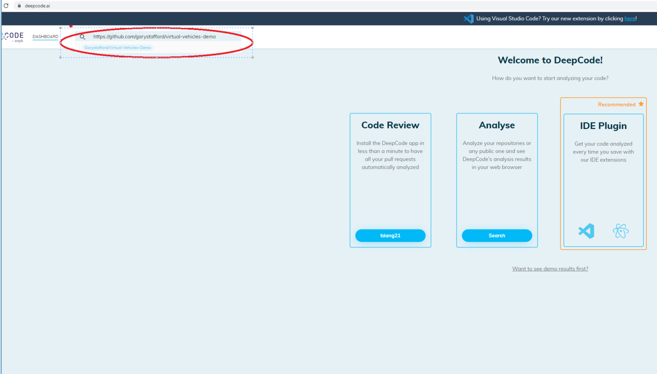

1. Result after using DeepCode AI online.

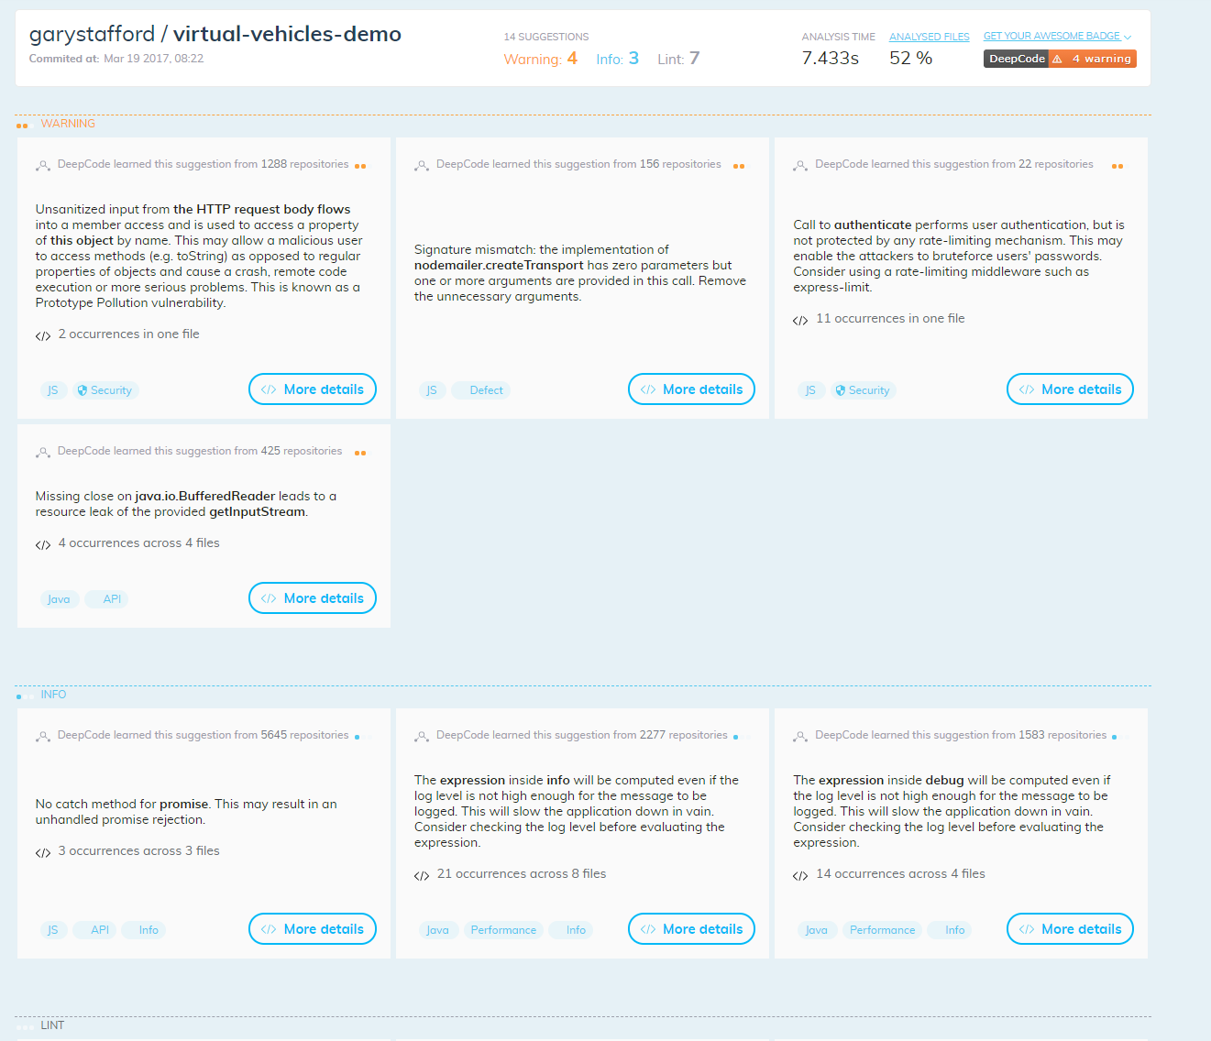

## 

## 

## 3.3 OWASP ZAP

1. Download the ZAP installer from OWASP’s website (for this project, we chose the Windows 64-bit version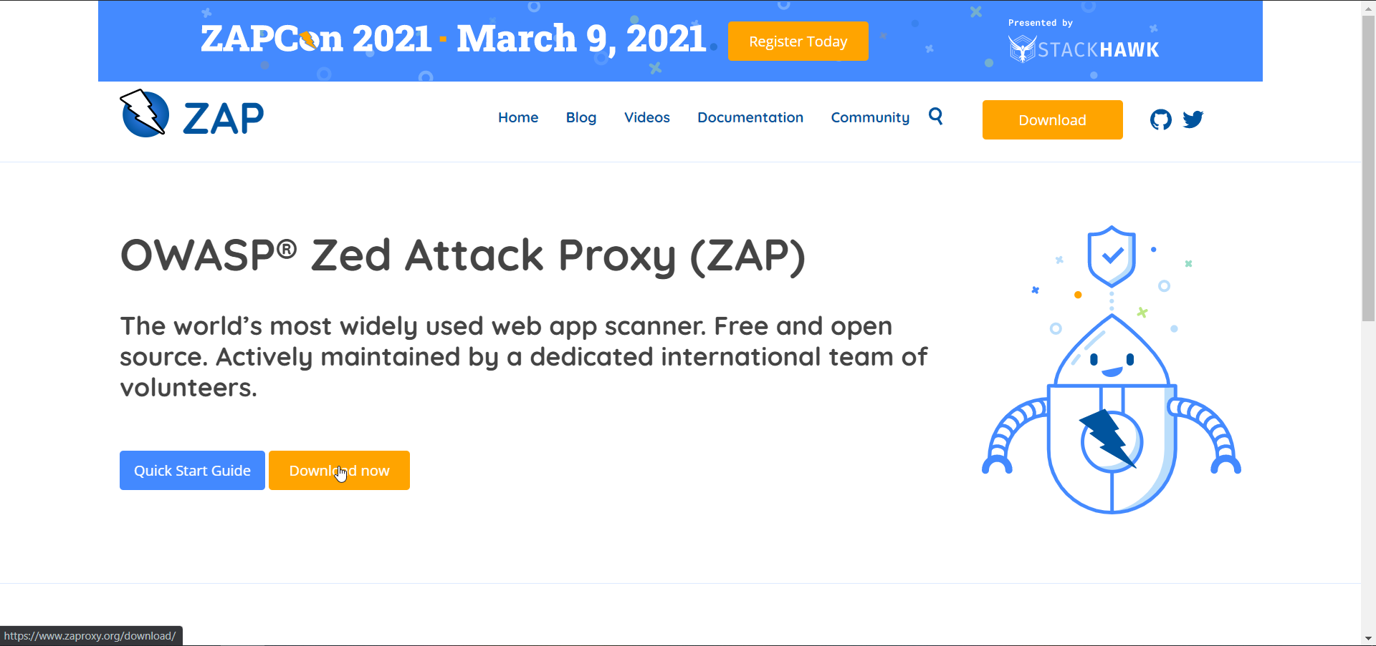

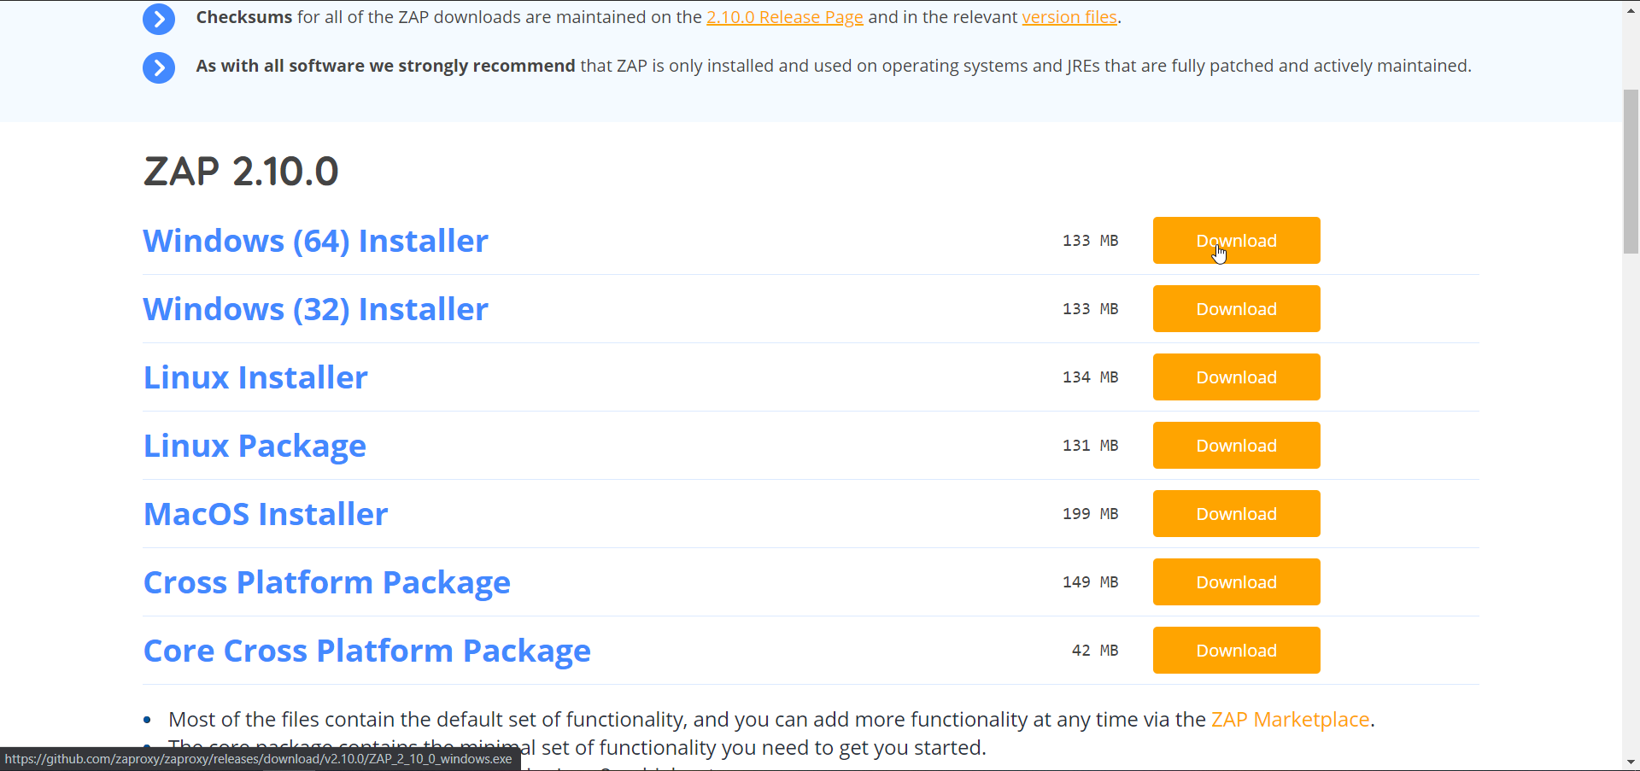

1. When running the installer, we chose the standard installation: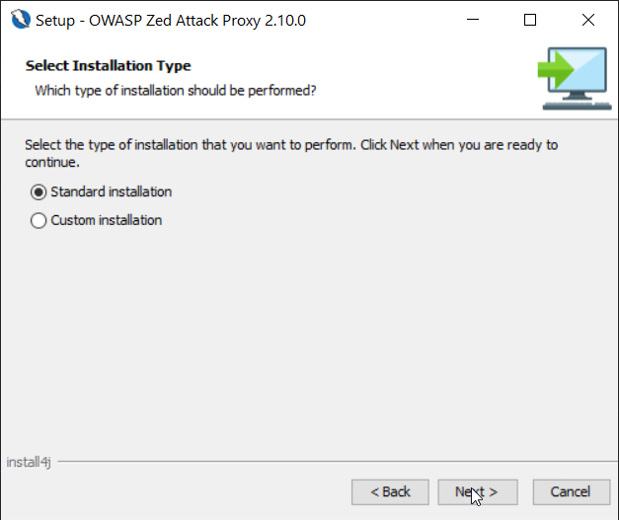

## 3.4 Snyk

1. In order to use Snyk, we have to use Snyk Open Source: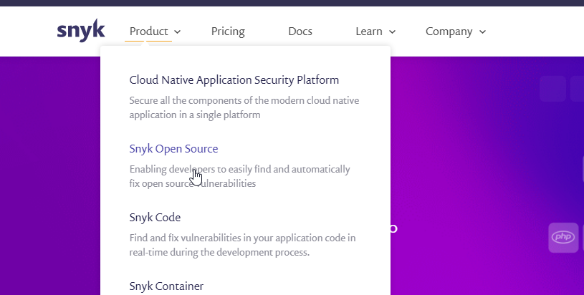
2. Choose “Quick Start”: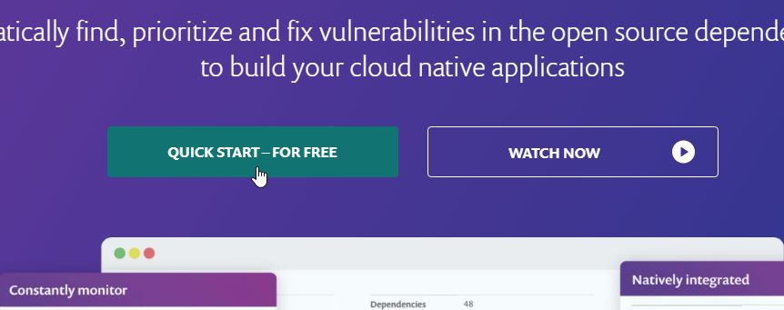
3. Log in through any of the choices presented (for this project, we select GitHub):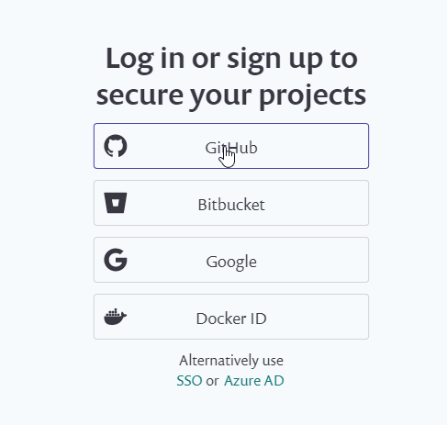
4. Clicking on “Add Project” will allow you to add any repositories you want to scan: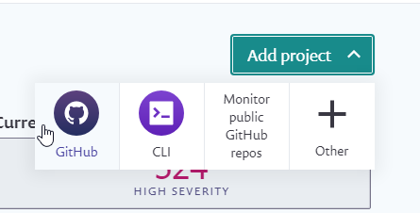

# 4. Miscellaneous

With Insomnia and being able to test the service that is provided, there are certain key points that must be taken to execute a new request. Down below is an example of the process of how to set up the new request.

Creating a Client Request Example:

1. Right Click on the tab on the left and get a pop up to start a new request.

* Ctrl+N can be used as a shortcut as well

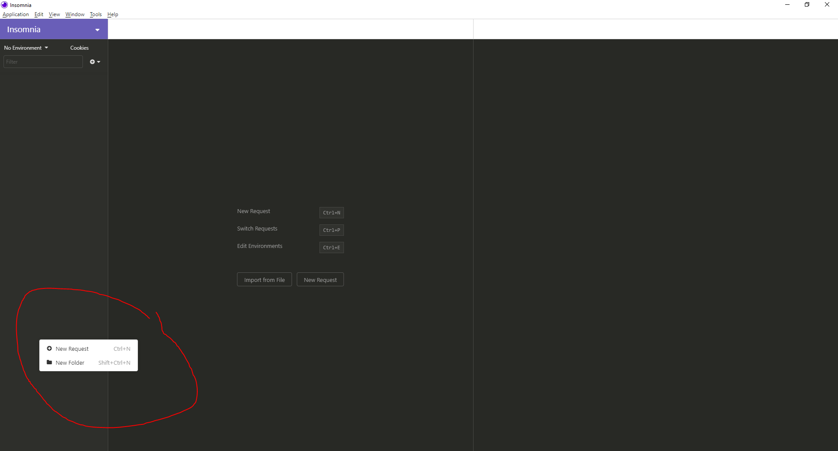

1. There will be a new pop up that will display “New Request '' with this pop up, you are able to name the request to what is needed. In this example, we will name it “ Create Client”  
     
   To the right of the bar is the type of method the request is. There will be a drop down list of methods where you will select the accordingly one that is right for the request.   
   For this example, “Create Client” in th API will be a POST method, with a POST method, it will ask what type of body, and the body we will select is a JSON text type.  
     
   To complete the initial set up, click “Create” on the bottom right of the pop up.

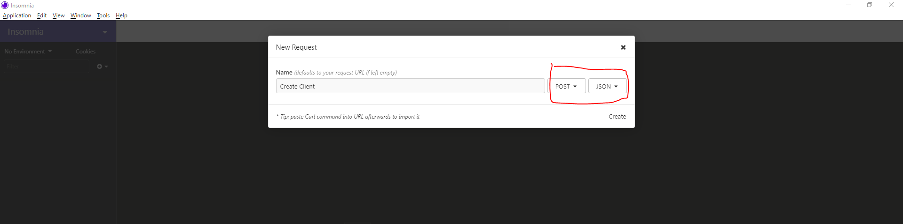

1. After the Setup is complete, when accessing the request, there will be a bar on top of the window. With this dropdown box, you can change the type of Method the request is if we need to access a different method  
     
   With the fill-in box, this is where we will type the URI address for the API request. This can be found on API guides.   
     
   For our example, the format for Create Client is “/clients.{format}”. The values can be found in the directory of the API system to get the value.

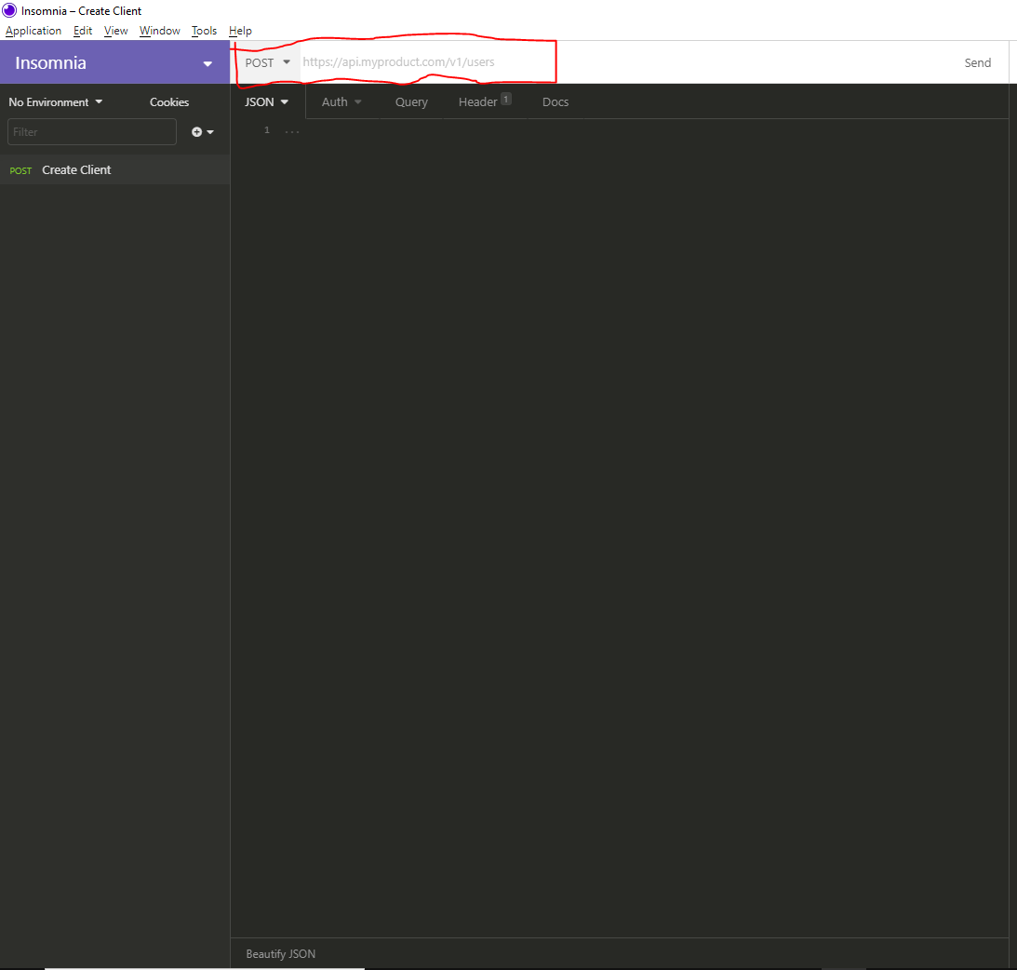

1. Depending on the type of method of the request, there will sometimes require a Request Body. This can be displayed on the section of the window. This is where we are able to put in code that will determine the output of the request as well depending on the API action.
2. When the request is completed and executed, there will be a preview of what will be displayed on the right side of the windows. This shows the element of the request.

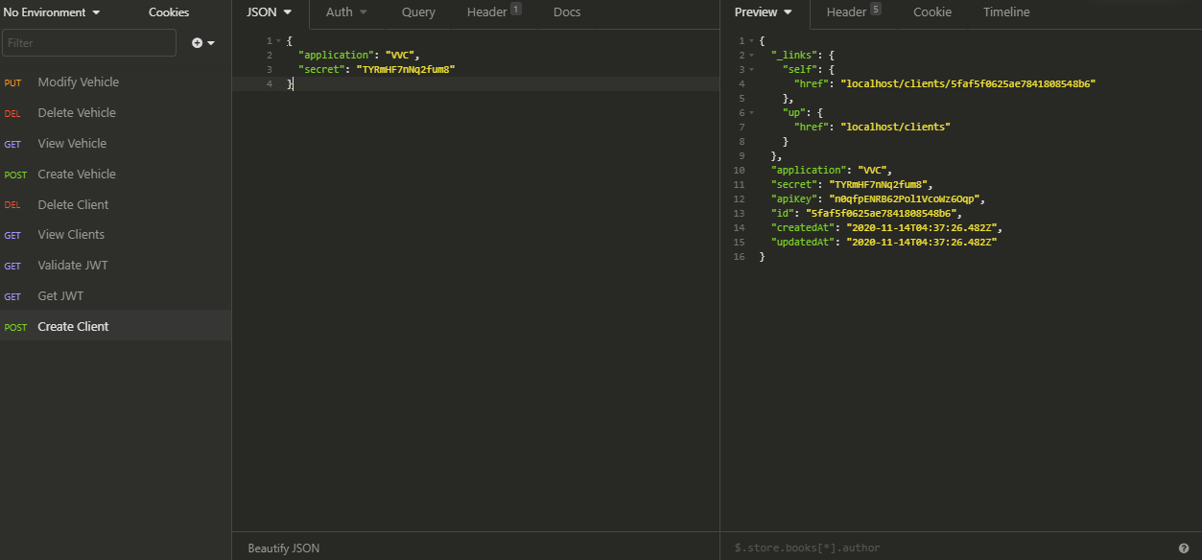

For References and the requests that we used can be found in the “Virtual­Vehicles REST API Documentation” WIth this document we are able to get the format of the request of Client Management and the vehicle services of our API System.

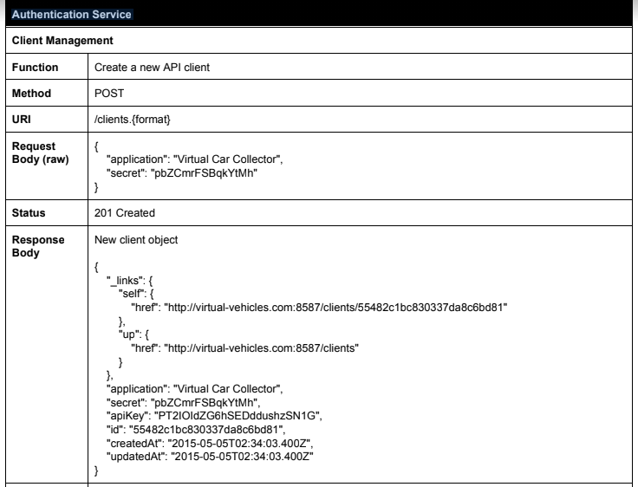

# 5. Code Samples

## 5.1 Input Validation and Data Sanitization

### 5.1.1 **Reliance on Default Encoding**

We want to keep a unified encoding scheme when reading and writing bytes from and to a stream. This way, there is a smaller chance of disagreement over character encodings which can cause data corruption. Additionally, the default encoding may not be suitable for a certain machine. Thus, the application may vary from platform to platform.

**Noncompliant Code**

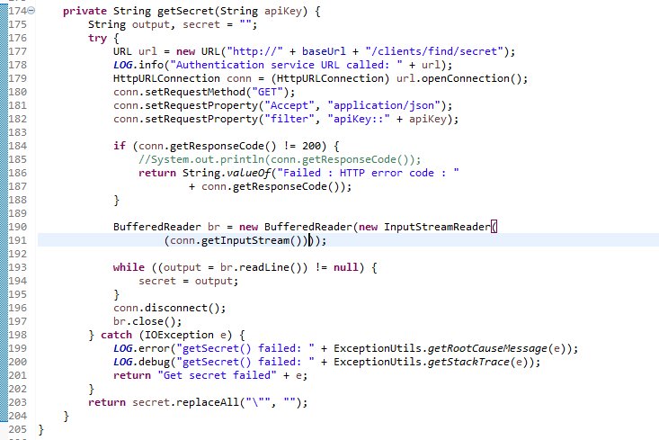The above code reads from an input string to get the secret associated with the client. It uses the default encoding which may differ from the encoding used to create the secret. SpotBugs is able to detect this issue as shown below.

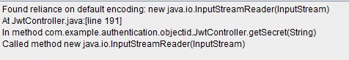

**Compliant Code**

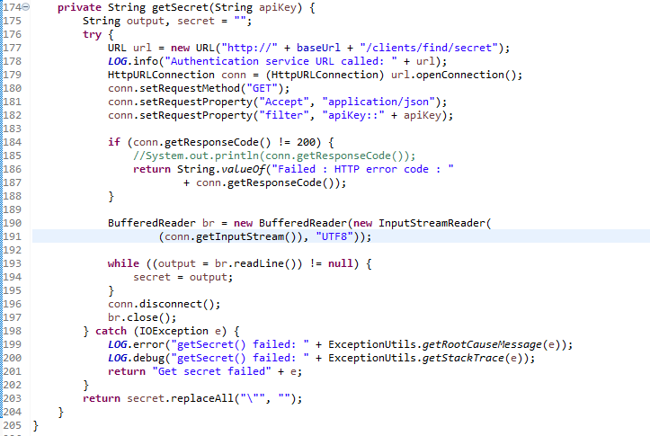

In the code listed above, we had a string identifying which encoding we wish to use. Throughout this API, UTF-8 encoding was used. Thus, we should use “UTF8” to signify the proper encoding. Running SpotBugs again showed that this error was resolved.

### 5.1.2 Check Validity of Retrieved Items (Parameter Tampering)

When retrieving items from a database based on a user query, we want to make sure the item is a valid item. Sometimes if an invalid item is retrieved, this can cause other portions of our application to crash. This can lead to sensitive information being made available to a malicious user.

**Noncompliant Code**

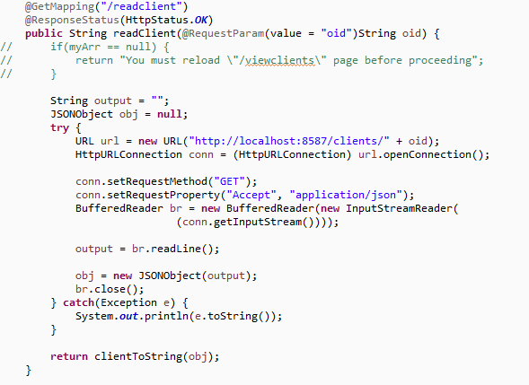

The above code makes a request to the Authentication microservice to read an existing client. However, the above code assumes the user will always ask for an existing client and does not take into account what would happen if the user asks for a client that does not exist. Using ZAP, we see that it is possible for a stack trace to be found with possible parameter tampering.

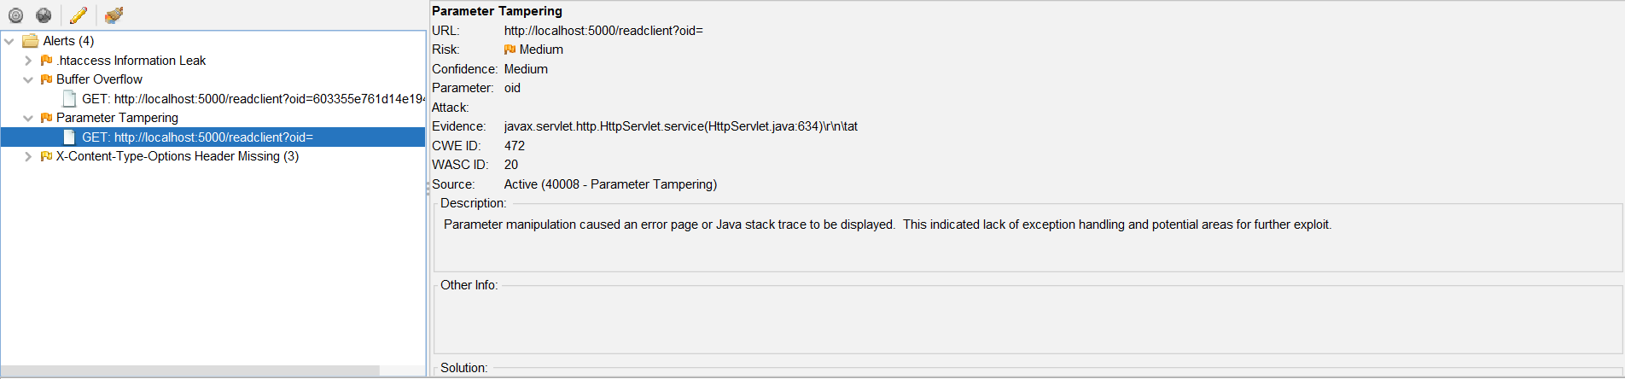

**Compliant Code**

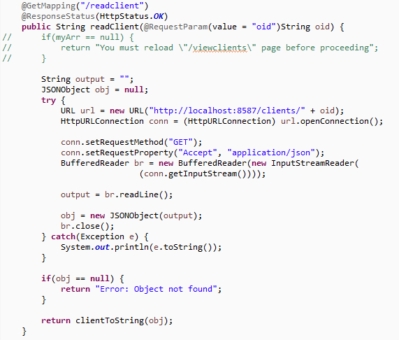

The above code implements a check to see if the client returned from the microservice is null and returns if the client is null. Given that the Authentication microservice will return a null JSON object if the object ID does not match any in its database, this takes care not to crash the application if a null client is returned. Running ZAP again, we see this error is resolved.

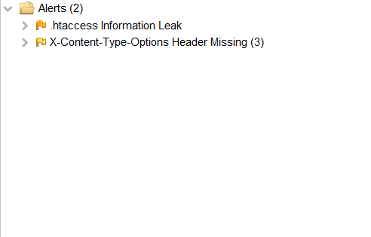

### 5.1.3 Check Validity of Retrieved Items (Path Traversal)

As with the previous section, we need to sanitize any data we receive. In this example, we have a function which makes a call to the Authentication microservice to validate a user input JWT. From the microservice, we retrieve a boolean variable of either true or false. Due to how this API call works, it will always attempt to process the user input. Not being mindful of this fact means that our function is exposed to attacks such as path traversal or cross-site scripting.

**Noncompliant Code**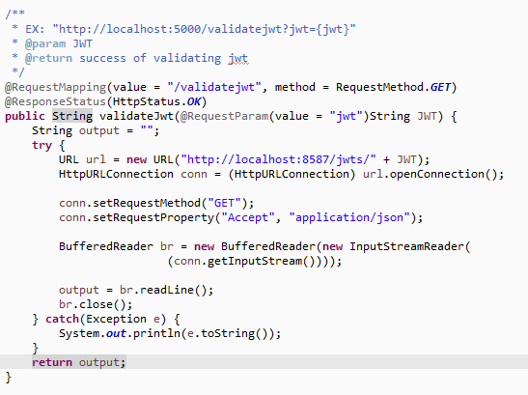

In the above code, we directly return the response read from the microservice and assume that the user will not give malicious input. Thus, this code is vulnerable to path traversal and cross-site scripting. Running ZAP, we can see that it found this function to be vulnerable to path traversal.

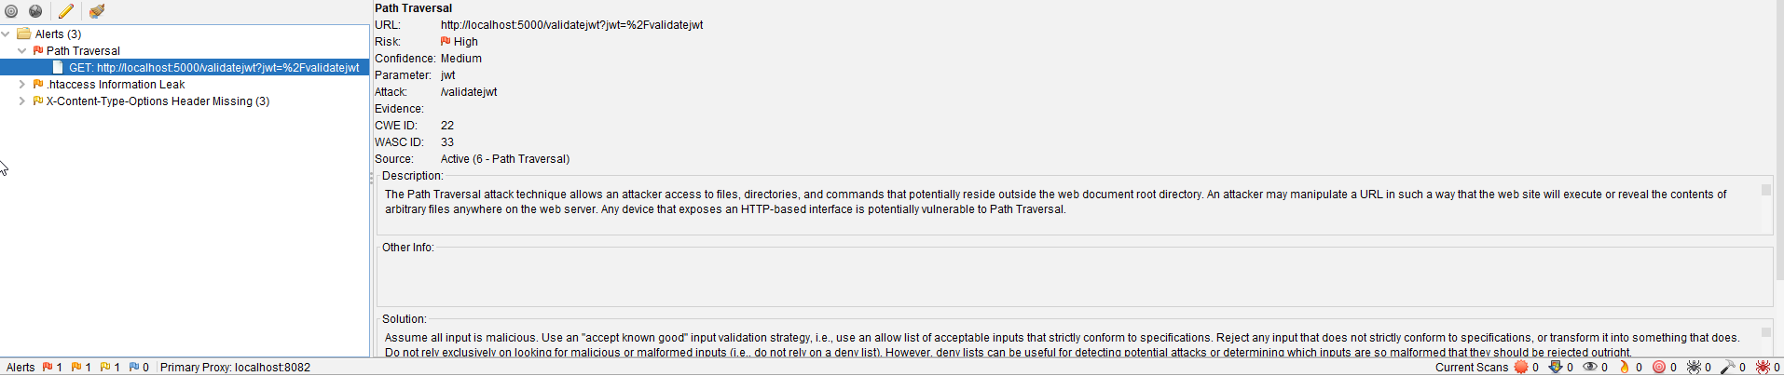

**Compliant Code**

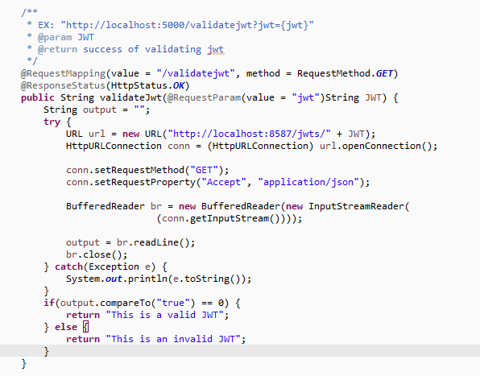

In the above code, we check the value returned by the API to see if it is an expected value. For the purposes of validating a JWT, we only need to check if the output value is “true”. Otherwise, we return immediately from the function and no further processing is done. Running ZAP again, we see that the path traversal error is gone.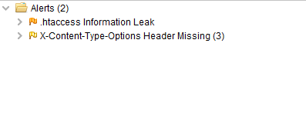

## 5.2 Methods

## 

### 5.2.1 An equals() Method Must Have A Corresponding hashCode() Method

Classes which override the Object.equals() method must also override the Object.hashCode() method. This way, when invoking the overridden method, there is more certainty that it will return the correct result. When hashCode() is not overridden, this violates the contract that equal objects must have equal hash codes which can result in unexpected performance.

**Noncompliant Code**

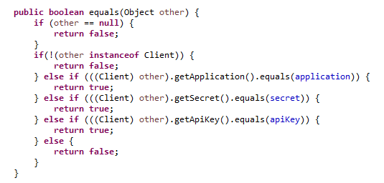

In the above code, equals() is provided but hashCode() is not. This bug can found easily when running SpotBugs.

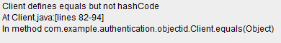

**Compliant Code**

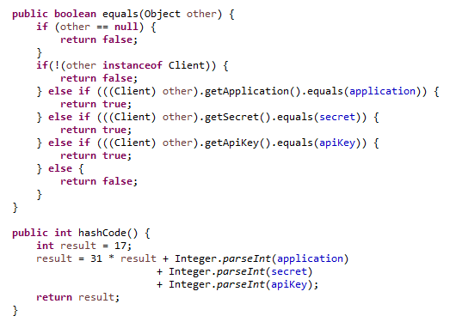

From the above code, we have added a hashCode() method. This will ensure that two identical objects will have identical hash values leading to the correct operation of the equals() method.

### 5.2.2 **Confusing Similar Signature**

When trying to implement a method that overrides an already existing method, such as Object.equals(), it is necessary to follow the general rules for that method. This includes naming schemes and parameter names. If these rules are not followed, that method may not function correctly when used with other Java code and may cause unexpected problems.

**Noncompliant Code**

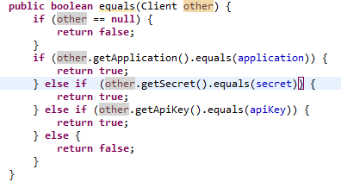

The above method aims to override the equals() method from the Object class. However, it assumes that the user will pass a Client object. If the user passes, some other object, the code may crash.

Using both DeepCode and SpotBugs, we can find this error:



**Compliant Code**

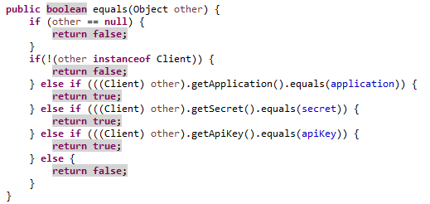

The above code demonstrates a more secure way to override the equals() method. This way, a user can pass a non-Client object without the code crashing or performing in some unexpected ways.

# 

## 5.3 Object Orientation

### 5.3.1 Do Not Use Public Static Nonfinal Variables

Public static variables can easily be accessed by client code. These types of values cannot be checked by any security managers or properly validated before they are stored in these variables. Additionally, these variables may behave in unexpected ways in a multithreaded environment. As a result, there are many unexpected ways these variables can be modified.

**Noncompliant Code**

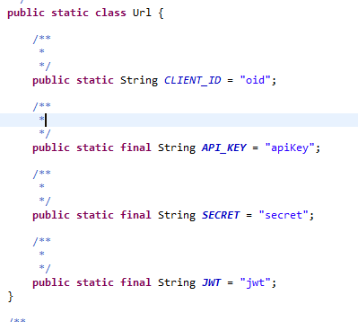

The above code sample is a modified version of the virtual vehicles API which declares the client ID as nonfinal. Using SpotBugs, we can easily detect this vulnerability.

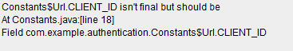

Also, we can use CheckStyle to spot this error. The second marker refers to a style specific issue.

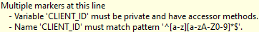

**Compliant Code**

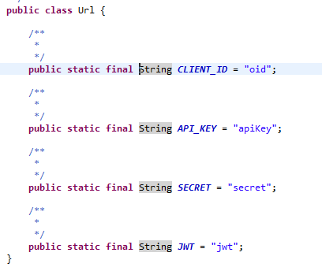

The code above demonstrates safer coding practices. We have declared the client ID as final. Using SpotBugs and CheckStyle, we can see that this issue is resolved.

## 5.4 Resources

# 

### 5.4.1 Close Any Resources After Their Use Is Over

You may need to allocate memory or other resources during the runtime of your code. However, when those resources are no longer needed, it is necessary to release those resources. If you do not release these resources, your code may have a significant slowdown. In the context of web services, you want to keep your code running as fast and smooth as possible. It would not be feasible to shut down the service every few hours just to free any unused resources. Thus, your code must, on its own, release resources that it does not need.

**Noncompliant Code**

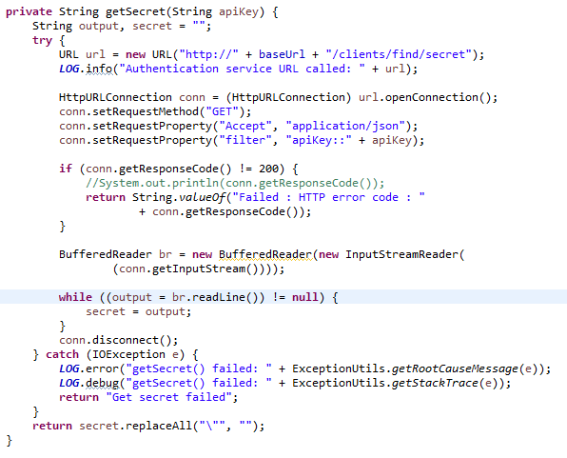

In the above code, we open a new BufferedReader to read from our input stream. However, we never close the BufferedReader upon exiting the method leading to a resource leak.

Using both SpotBugs and DeepCode, we can find this error.



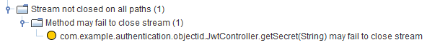

**Compliant Code**

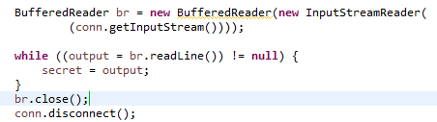

In the above code, we close the BufferedReader when we are done with it allowing other programs to use those resources and making our web service have better performance.

# **References/Download Links**

Reference Article:

<https://programmaticponderings.com/2015/05/18/building-a-microservices-based-rest-api-with-restexpress-java-and-mongodb-part-1/>

Virtual Vehicles Source Code:

<https://github.com/garystafford/virtual-vehicles-demo>

Java SE and JDK Downloads:

<https://www.oracle.com/java/technologies/javase-downloads.html>

Apache Maven Downloads:

<https://maven.apache.org/download.cgi>

Eclipse for Java EE

<https://www.eclipse.org/downloads/packages/release/2020-09/r/eclipse-ide-enterprise-java-developers>

Git:

<https://git-scm.com/>

MongoDB Community Server

<https://www.mongodb.com/try/download/community>

Insomnia Download:<https://www.mongodb.com/try/download/community>

<https://insomnia.rest/download/#windows>

RestExpress Source:

<https://github.com/RestExpress/RestExpress>

RestExpress Jar File:

<https://search.maven.org/artifact/com.strategicgains.archetype/restexpress-mongodb/1.15/maven-archetype>

Netty:

<https://netty.io/index.html>

Apache Logging:

<http://logging.apache.org/log4j/2.x/>

JUnit:

<https://junit.org/junit5/>

SpotBugs zip:

<https://spotbugs.readthedocs.io/en/latest/installing.html>

Deepcode:

<https://www.deepcode.ai/>

OWASP ZAP:

<https://www.zaproxy.org/>

Snyk:

<https://snyk.io/>